|  |  |
| --- | --- |
|  | **VIDEO STEGANOGRAPHY USING**  **LSB TECHNIQUE**  **BACHELOR IN COMPUTER SCIENCE (HONS)**  **MANAGEMENT & SCIENCE UNIVERSITY**  **2023**  **LEE YUNG YAU** |

**BACHELOR IN COMPUTER SCIENCE (HONS) 2023**

# **DECLARATION**

***(PENGISYTIHARAN)***

I, *Saya,*

______LEE YUNG YAU______

Candidate for the degree of, *Calon bagi ijazah*

______BACHELOR IN COMPUTER SCIENCE (HONS)______

Management & Science University certify that:

*Management & Science University mengakui bahawa:*

1. My thesis was personally developed, conducted and written by myself under the supervision of

*Tesis saya/kami telah dijalankan, digubal dan ditulis sendiri di bawah penyeliaan:*

____ Assoc Prof. Ts. Dr. Asif Iqbal_____

1. My data are original and personally collected and analysed and

*Data saya adalah data asal dan saya sendiri mengumpul dan menganalisisnya: dan*

1. I shall at all times be governed by the conditions, policies and regulations of the MSU on thesis writing, including the copyright and Patent laws of Malaysia.

*Saya akan sentiasa mematuhi syarat, polisi dan peraturan MSU mengenai penulisan tesis, termasuk undang-undang Hakcipta dan Paten Malaysia.*

In the event that my/our thesis be found to violate the conditions mentioned above, I/we voluntarily waive the right of conferment of my/our degree and be subjected to the disciplinary rules and regulations of Management & Science University.

Jika saya/kami didapati melanggar perkara-perkara di atas, saya/kami dengan relanya menepikan hak penganugerahan Ijazah saya/kami dan tertakluk kepada syarat dan peraturan disiplin Management & Science University.

_________________ __________________ ___________________

Candidate’s Name Candidate’s Signature Date

*Nama Calon Tandatangan Calon Tarik*

# **CERTIFICATION OF PROJECT PAPER**

*(Perakuan Kerja Kertas Projek)*

I, the undersigned, certify that, *(Saya, yang bertandatangan, memperakukan bahawa)*

__________LEE YUNG YAU___________

candidate for the degree of, (*calon untuk Ijazah)*

________BACHELOR IN COMPUTER SCIENCE (HONS)_______

has presented his/her project paper of the following title

*(telah mengemukakan kertas projek yang bertajuk)*

_____VIDEO STEGANOGRAPHY USING LSB TECHNIQUE______

as it appears on the title page and front cover of the project paper

*(seperti yang tercatat di muka surat tajuk dan kulit kertas projek)*

that the project paper is acceptable in form and content, and that a satisfactory knowledge of the field is covered by the project paper.

*(bahawa kertas projek tersebut boleh diterima dari segi bentuk serta kandungan, dan meliputi bidang ilmu dengan memuaskan.)*

Name of Supervisor

*(Nama Penyelia) :* ____________________________________________________

Signature

*(Tandatangan) :* ____________________________________________________

Date

*(Tarikh) :* ____________________________________________________

# **Table of Contents**

**Page**

ABSTRACT (English Version) V

ABSTRAK (Malay Version) VI

ACKNOWLEDGEMENT VII

LIST OF FIGURES VIII

LIST OF ABBREVIATIONS IX

LIST OF TABLES X

**CHAPTER**

**I INTRODUCTION** 1

1.1 Background of the Project 1

1.2 Problem Statement 1

1.3 Objectives of the Project 2

1.4 Significance of Project 2

1.5 Scope of the Project 3

1.5.1 User Scope 3

1.5.2 System Scope 4

1.6 Assumptions and Limitations 5

**II LITERATURE REVIEW**  7

2.1 Introduction 7

2.2 Review of the Current Situation 7

2.3 Review of Related Literature 10

2.3.1 Least Significant Bit 11

2.3.2 Advanced Encryption Standard (AES) 12

2.3.3 Peak Signal-to-Noise Reduction (PSNR) 13

2.3.4 Reed-Solomon 14

2.4 Review of Related Products 15

2.4.1 OpenPuff 15

2.4.2 Our Secret 18

2.4.3 StegoStick 20

**III RESEARCH DESIGN AND METHODOLOGY** 23

3.1 Introduction 23

3.2 Development Methodology 23

3.3 Hardware and Software Requirements 25

3.4 Project Schedule 25

3.5 UML (Unified Modelling Language) 27

3.6 User Interface Design (UI/UX) 33

3.7 Summary 34

**IV RESULTS AND DISCUSSIONS** 36

4.1 Introduction 36

4.2 Testing Approach and Environment 36

4.3 Results 37

4.4 Summary of Findings and Discussion 44

**VI CONCLUSION AND FUTURE RECOMMENDATIONS** 45

5.1 Conclusion 45

5.2 Future Recommendations & Improvements 46

**V REFERENCES AND BIBLIOGRAPHY** 47

# **Abstract (English Version)**

Abstract of the project presented to the Senate of Management & Science University in partial fulfilment of the requirements for the Bachelor in Computer Science (Hons.)

Faculty: Information Sciences and Engineering

Video steganography is a vital medium for covert communication, which enables the hiding of confidential and secret data within video files while preserving their visual quality. The Least Significant Bit (LSB) technique has been widely used in video steganography due to its simplicity and efficiency. However, existing LSB-based systems suffer from limitations such as low embedding capacity and vulnerability to steganalysis attacks. The proposed project presents a more comprehensive approach to address these challenges and develop an enhanced video steganography system using the LSB technique. One of the primary objectives of the project is to further increase the embedding capacity while maintaining the visual integrity of the video. Additionally, with advanced LSB embedding techniques and encryption mechanisms, the systems maximize the amount of data that can be hidden within the video while safeguarding its security and confidentiality. Rigorous testing and evaluation validate the system’s performance and demonstrate its effectiveness in securely embedding and extracting hidden data within video files. The developed video steganography system utilizing the LSB technique offers an efficient and reliable solution for covert communication. The project report aims to showcase the reliability and efficiency of the developed video steganography system, thereby contributing a refined and reliable video steganography system that aligns with contemporary security and communication needs without compromising the integrity of the content.

Keywords: Least Significant Bit (LSB), Cover image, Stego-image, Mean Square Error (MSE), Peak Signal to Noise Ratio (PSNR)

# **Abstrak (Versi Bahasa Malaysia)**

Steganografi video adalah medium penting untuk komunikasi tersembunyi, yang membolehkan penyembunyian data rahsia dan sulit dalam fail video sambil menjaga kualiti visualnya. Teknik Bit Paling Kurang Signifikan (LSB) telah digunakan secara meluas dalam steganografi video disebabkan kesederhanaan dan kecekapan teknik tersebut. Walau bagaimanapun, sistem yang berdasarkan LSB yang sedia ada menghadapi kekangan seperti kapasiti penyisipan yang rendah dan kerentanan terhadap serangan steganalysis. Projek yang dicadangkan ini menyajikan pendekatan yang lebih komprehensif dalam menangani cabaran ini dan membangunkan sistem steganografi video yang lebih baik menggunakan teknik LSB. Salah satu objektif utama projek ini adalah untuk meningkatkan kapasiti penyisipan sambil mengekalkan integriti visual video tersebut. Selain itu, dengan menggunakan teknik penyisipan LSB yang canggih dan mekanisme enkripsi, sistem ini memaksimumkan jumlah data yang boleh disembunyikan dalam video sambil menjaga keselamatan dan kerahsiaannya. Ujian dan penilaian yang teliti memvalidasi prestasi sistem dan menunjukkan keberkesanannya dalam menyisipkan dan mengekstrak data tersembunyi dalam fail video dengan selamat. Sistem steganografi video yang dibangunkan menggunakan teknik LSB ini menawarkan penyelesaian yang efisien dan boleh dipercayai untuk komunikasi tersembunyi. Laporan projek ini bertujuan untuk menunjukkan kebolehpercayaan dan kecekapan sistem steganografi video yang dibangunkan, dengan itu menyumbang kepada sistem steganografi video yang lebih sempurna dan boleh dipercayai yang selari dengan keperluan keselamatan dan komunikasi kontemporari tanpa mengorbankan integriti kandungan.

Kata Kunci - - Bit Paling Tidak Signifikan, Imej Asas, Imej Stego, Purata Ralat Kuasa Dua, Nisbah Puncak Isyarat kepada Nisbah Kebisingan

# **Acknowledgements**

My sincere appreciation and respect go out to my supervisor Assoc Prof. Ts. Dr. Asif Iqbal and evaluator Dr. Mir for all of their help, advice, and helpful recommendations with unwavering support in making this study. Additionally, I want to express my gratitude to the faculty member for their inspiration and assistance. Additionally, I would like to express my gratitude to the authors of the studies and articles that have been cited in this project because their work has been a tremendous aid in understanding the theories and methods underlying video steganography using the LSB (Least Significant Bit) technique.

Finally, I would like to acknowledge the support of my family and friends, who have been a constant source of motivation and encouragement throughout the project. Their unwavering support has been instrumental in helping me overcome the challenges I have faced during the development of this project.

# **List of Figures**

**Figures Page**

**2.1** Equation for Stega-Video Signal 11

**2.2**  Example of Least Bit Substitution and its Explanation 12

**2.3 Interface for OpenPuff 16**

**2.4 Interface for Selecting Data for Hiding 16**

**2.5 Interface for Carrier Selection 17**

**2.6 Interface for Embedding Hidden Data 17**

**2.7 The process of hiding Carriers 18**

**2.8 Our Secret – Add Files or Messages 19**

**2.9 Our Secret – Enter the Password to Hide Messages 19**

**2.10 Our Secret – Steps to Unhide 20**

**2.11 StegoSticks Interface 21**

**2.12 StegoSticks – Hide Files 21**

**3.1** Agile methodology development cycle 24

**3.2** Use Case Diagram 27

**3.3 Class Diagram 28**

**3.4 Sequence Diagram 29**

**3.5 Activity Diagram 30**

**3.6 Flowchart – Video Steganography App 31**

**3.7 Flowchart – Video Extractor App 32**

**3.8** Web application main page 33

**3.9** Video Steganography App – User Interface 33

**3.10** Video Text Extractor App – User Interface 34

**4.1** Video Steganography Interface with Test Results for 480p Video File 37

**4.2** Video Processing Log with Final Test Results for 480p Video File 37

using MoviePy

**4.3** Original 480p Video 38

**4.4** Stego-Video for 480p 38

**4.5** Video Steganography Interface with Test Results for 720p Video File 39

**4.6** Video Processing Log with Final Test Results for 720p Video File 39

using MoviePy

**4.7** Original 720p video 40

**4.8** Stego -Video for 720p 40

**4.9** Video Steganography Interface with Test Results for 1080p Video File 41

**4.10** Video Processing Log with Final Test Results for 1080p Video File 41

using MoviePy

**4.11** Original 1080p video 42

**4.12** Stego-Video for 1080p 42

**4.13** Comparison Table for Processing Time Between Video Resolution 43

# **List of Abbreviations**

**Abbreviation Definition**

LSB Least Significant Bit

AES Advanced Encryption Standard

PSNR Peak Signal-to-Noise Ratio

BPP Bits Per Pixel

MSE Mean Squared Error

HCV Histogram Constant Value

MP4 MPEG-4

RGB Red, Green, Blue

# **List of Tables**

**Table Page**

**2.1** Comparison of the proposed method with surveyed 10

video steganography techniques

**2.2** Comparison of related products 12

**2.3** AES Key Size with Key length, Block Size and Number of rounds 13

# **CHAPTER I**

# **INTRODUCTION**

Steganography is the art/science of hiding the existence of the communication between the sender and the receiver. The word steganography comes from the Greek words Steganós (Covered) and Graptos (Writing) and means "hidden writing" (R. Anderson, and F. Petitcolas,1998) [1]. Video steganography is a branch of information hiding focusing on concealing confidential or sensitive data within video frames while maintaining visual quality. Similar to image steganography, video steganography aims to hide data within the video frames so that the changes are invisible to human observers. (Kunhoth, J., Subramanian, N. Al-Maadeed,2023) [2] One of the widely used techniques in video steganography is the Least Significant Bit (LSB) embedding technique. The technique of hidden messages mentioned is used to counter the attacks on data and provide security, privacy, confidentiality, and integrity to the data's sensitivity. (Al-Khater WA, Al-Maadeed S, Ahmed AA et al (2020)) [3]. LSB techniques are particularly designed for robust digital image watermarking, making them effective in steganography for hiding secret data (Poorani & Jawagar, 2014) [4].

# **1.1 Background of the Project**

The background proposal for Video Steganography Using the LSB technique was driven by the increasing need for more secure communication, and data protection, which the main application areas of video steganography change from the defence industry to copyright control. The main ground behind the widespread usage of video steganography is due to fact that the people can’t distinguish little changes in digital video. (Mstafa, Elleithy & Abdelfattah (2017)) [5]. LSB-based steganography has become widely adopted due to its simplicity and effectiveness. The technique involves individually modifying the least significant bit (LSB) of pixel values in the digital representation of a video frame.

The Least Significant Bit represents the binary digit with the least significance or contribution to the overall value of the pixel. By replacing each specific bit with a bit of the hidden information, the technique allows for the embedding of secret information within the cover media.

Since the modification is subtle and minimal alteration caused to the pixel value. The visual distortion introduced by the technique does not cause perceptual differences and is imperceptible to human eyes or observers, thus serving as a robust method for transmitting sensitive information. (Paul, Acharya, Yadav, & Batham, 2013).[6]

This project aims to explore and develop an efficient and reliable implementation of the LSB technique for video steganography by combining it with other complementary and effective techniques. Some of which are commonly used approaches such as encryption algorithms like Advanced Encryption Standard (AES) or Reed-Solomon can be used to encrypt the secret message, making it more resistant to unauthorized access or decryption.

# **1.2 Problem Statement**

1. Current mechanisms for video steganography solutions lack optimization due to increased computational complexity and potential degradation of video quality during embedding text.
2. Not only that, current video steganography tools require users to possess some level of technical proficiency, posing a barrier for individuals with limited technical expertise. The complexity of these tools may lead to unintended errors during the embedding or extraction processes, potentially compromising the integrity of the hidden information and diminishing the overall user experience.
3. Embedding text into video frames using the LSB method is not sufficient to ensure security. The LSB method, while a common approach in steganography, is susceptible to detection through statistical analysis and visual inspection. Its simplistic nature makes it more prone to potential misuse or privacy breaches, as adversaries can exploit patterns and inconsistencies in the modified LSBs to uncover hidden information.

# **1.3 Objectives**

To optimise the effectiveness of the LSB technique in video steganography, we can achieve our goals by implementing the following objectives:

1. Develop and implement mechanisms for the efficient handling of large video files. This involves optimizing algorithms and employing advanced data processing techniques to ensure smooth integration of the LSB technique without compromising the integrity and quality of the original video content.
2. User-friendly steganography process by providing an intuitive interface for users to select video files, input and encrypt text, and choose specific frames for data embedding. This simplicity makes the complex process of video steganography accessible to users regardless of their technical expertise.
3. Embed text into video frames using the LSB method while prioritizing security through Advanced Encryption Standard (AES) encryption. Strengthen the encryption by integrating user-provided passwords, adding an extra layer of protection to the embedded information. Additionally, implement Reed-Solomon error correction to enhance the reliability of data extraction and decryption processes. This strategic combination ensures not only the confidentiality of the hidden information but also fortifies the system against potential data loss or corruption during the steganographic process.

# **1.4 Significance of the Project**

The significance of the project lies in its ability to offer a practical solution for secure and covert communication through video files. By leveraging the LSB techniques, this study addresses the need for robust and reliable video steganography techniques, fostering data protection, privacy, and secure communication in various applications and domains.

Firstly, it enables secure communication by allowing the embedding of secret information within video files, ensuring the confidentiality and integrity of hidden and sensitive data. This is crucial in the modern digital age when privacy violations and unauthorised information access are one of the major concerns. The project offers a workable option for people and organisations to safeguard their information during transmission and storage by utilising LSB technology. Secondly, the project addresses the need for covert communication. Covert communication refers to the transmission of information without raising suspicion or attracting attention.

By combining video steganography with LSB techniques, users may hide sensitive information within video files, rendering it indistinguishable from the human eye.

This has important uses in several fields, including intelligence gathering, law enforcement, and private commercial communications where covert communication is crucial. The research makes a significant contribution to the development of reliable and effective covert communication systems by successfully implementing the LSB algorithm, guaranteeing that sensitive information may be conveyed safely and covertly without being discovered.

# **1.5 Scope of the project**

The scope of the project focuses mainly on the development of a video steganography system that mainly uses the Least Significant Bit (LSB) technique. The project aims to enhance the embedding capacity, strengthen security, and ensure robustness and effectiveness by embedding hidden text within MP4 video files.

The system will provide an interface for a seamless embedding and extraction process. The scope includes extensive testing and evaluation of multiple video frames to assess the system’s performance, security, and reliability.

The outcomes of the study will showcase and contribute to the field of video steganography by improving and offering a more simple, fast and secure steganography system that enables secure and covert communication within video files.

## **1.5.1 User scope**

The user scope for Steganography using the Least Significant Bit (LSB) Technique for video files involves the development of a software tool that can efficiently embed and extract hidden information in video files using the LSB technique.

The investigation of the trade-off between the amount of information that can be hidden and the quality of the video file, and the development of strategies to optimize this trade-off.

Analysis of the LSB technique’s robustness to steganalysis methods and exploration of methods to strengthen the security of the hidden information.

By evaluating the LSB technique’s compliance with various video file formats and investigating substitute steganography methods that support a broader variety of video file formats. The development of educational and training materials goals is to give users the skills and knowledge they need to use the LSB technique ethically and responsibly. This includes helping users comprehend the technical and moral implications of doing so. Demonstration of the real-world uses of the LSB method for video files in various industries, including digital investigations, national security, and digital forensics.

## **1.5.2 System scope**

The system scope involved for video steganography using the LSB (Least Significant Bit) technique involves the various components required to implement the technique. The components can be broadly classified into hardware and software components.

Hardware components

1. Video capture devices where a video capture device is required to capture the video frames that will be used for steganography.
2. A basic computer system for processing video files and implementing the steganography technique.

Software components

1. Video editing software to select and extract the appropriate frames from the video file and manipulate the pixels to determine the least significant bit of each pixel and embed the secret data into it.
2. Compression software may be required to reduce the size of a video file after the steganography process. Lastly, decoding software is required to extract the hidden data from the video file.

The system scope for video steganography using the LSB technique also includes the various steps involved in the steganography process such as:

1. **Video Selection:**

Choose a video file, often referred to as the "cover video," in which you want to hide information. This video will serve as the carrier for your hidden data.

1. **Hidden Text**

Determine the secret text or message that you want to conceal within the video. There’s no limit on the number of words.

1. **Frame Selection:**

Decide which frames of the video you will use for embedding the hidden data. You can choose specific frames or distribute the data across multiple frames.

1. **LSB Embedding:**

Implement the LSB technique by altering the least significant bit of the pixel values in the selected frames. Typically, the secret text is in binary form, and each bit is substituted for the LSB of the pixel. This process is done without causing noticeable visual changes to the video.

# **1.6 Assumptions & Limitations**

The project assumption revolves around some of the points as follows:

* Video files used in the project may show uncompressed or compressed with lossless compression algorithms to ensure that the hidden information is not lost during compression.
* The video files used in the project may not be subject to any immediate modifications, such as resizing or cropping after the hidden information is embedded. The techniques used in this project revolve around video files.
* The default video format considered for this project is the MP4 format. It is assumed that users possess a fundamental understanding of video file formats, enabling them to access the original video file for secret data extraction using the same steganography tool initially employed for embedding. Additionally, it is assumed that users have a secure method for transmitting the video file containing embedded secret data to the intended recipient.
* Finally, a foundational assumption is made that the video steganography process is intended for legitimate purposes and not for any illegal or unethical activities, emphasizing its use for benign and lawful applications.

While the assumption may potentially bring out the benefits of this project, here are some of the limitations of this project, such as:

* The amount of information that can be hidden in the video file is limited by the size of the video file and the number of LSBs used to hide the information. Therefore, the technique may not be suitable for hiding large amounts of data.
* The Least Significant Bit (LSB) technique can have an impact on the quality of the video file, especially if a large number of LSBs are used to hide information.
* The LSB technique may pose as vulnerable to steganalysis attacks, which can reveal the presence of hidden information. Therefore, the technique may not be suitable for applications that require a high level of security.
* While the compatibility of the Least Significant Bit (LSB) technique with different video file formats may vary, and some formats may not be suitable for the technique.
* Lastly, the performance of the software tool developed in the project may depend on the hardware and software configurations of the system on which it is installed.

**CHAPTER II**

# **LITERATURE REVIEW**

**2.1 Introduction**

The literature review for the project “Video Steganography Using Least Significant Bit (LSB)” aims to look into a repository of published research on video steganography techniques, with a special focus on the LSB technique. The review will provide a comprehensive overview of the state-of-the-art in video steganography, highlighting its advantages, drawbacks, and developments for embedding hidden information into video files that utilise the LSB technique. The literature review will introduce the concept of video steganography and Its significance in secure communication and the covert transmission of data. The review will also emphasize the relevance of the LSB algorithm, a widely used technique in video steganography, due to its simplicity, effectiveness, and imperceptibility. The paragraph will set the foundation for exploring the literature by highlighting the research gap and the need to further investigate the use of LSB in video steganography.

# **2.2 Review of the Current Situation**

Video Steganography using Least Significant Bit (LSB) techniques is a widely experimented area in the field of data security transmission and covert communication. The current situation may reflect the widespread usage in research, advancements, and practical applications related to Least Significant Bit (LSB) based video steganography. Recently, researchers tried to improve the security of LSB in video steganography by introducing sequential encoding and decoding-based video steganography. (Ramalingam & Isa (2014)) [9]. The method requires video preprocessing operation. The best Peak Signal-to-Noise Ratio (PSNR) ratio and Mean Square Error (MSE) values were obtained as 71.52 dB and 0.01, respectively. At this best ratio, the payload was 0.11 bits per pixel. The advantage of the method is that it is simple to implement whereas the drawback of the method is less security.

Here's the comparison table of the proposed method with surveyed video steganography techniques:

|  |  |  |  |  |
| --- | --- | --- | --- | --- |
| **Studies** | **PSNR (Peak Signal-to-Noise Ratio) (decibel)** | **Payload (bits per pixels/%)** | **MSE (Mean Squared Error)** | **Robustness results** |
| **Ramalingam & Isa (2014) [9]** | Best value 71.52 | Best value 0.11 | Best Value 0.01 | Not robust enough against signal processing, noise, physical operation, statistical attacks and compression |
| **Kapoor & Mirza (2015) [16]** | Best value 52.94 | Average Value 2.66 | Best Value 0.33 | Not robust enough against signal processing, noise, physical operation, statistical attacks and compression |
| **Kelash et al. (2013) [10]** | Best value 48.84 | Average Value 1.1 | - | Not robust enough against signal processing, noise, physical operation, statistical attacks and compression |
| **Sadek, Khalifa & Mostafa (2015) [12]** | Average Value 1.1 | Average Value 1.1 | - | Robust against MPEG-4 codec |
| **Alavianmehr et al. (2012) [14]** | Average Value 1.1 | Average Value 1.1 | - | Robust against H.264/AVC codec |

**Table: 2.1: Comparison of the proposed method with**

**surveyed video steganography techniques.**

Recent studies have also shown dividing secret messages into chunks of 2 bytes and embedding the 2 bytes of the message into the first two pixels of the frame starting from the first frame (1 byte each pixel). The best PSNR ratio and MSE values were obtained as 52.94 dB and 0.33, respectively. The payload was calculated as 2.66 bits per pixel for all sizes of videos. Since only the first two pixels of each video frame were used for data hiding the method is quite vulnerable to statistical attacks. In another study, researchers proposed a steganography algorithm based on colour histograms for the data embedding into the video clips directly. The histogram constant value (HCV) is calculated by using all frames of the cover video. HCV is not only used for the selection of the frames in which the data will be embedded but also data embedding process. The selection of the frames is implemented by choosing the frames whose histogram variation is higher than HCV. The next stage is based on segmenting these frames into blocks to see the changes between successive pixels. The final step is to hide secret data into 3 LSB of each determined pixel. According to the hiding capacity (average payload ratio is 1.1%), this method is restricted because it is only based on the HCV value.

The average PSNR ratio was obtained as 48.84 dB (Kelash et al., 2013; Mstafa & Elleithy, 2016a) [10]. There’s also been a proposal on a technique that takes eight bits of the data at a time and conceals them in LSBs of RGB (Red, Green, and Blue) pixel values of the carrier frames in 3, 3, 2 order respectively. The authors obtained the best PSNR and MSE values as 53.04 dB and 0.32, respectively. The authors claimed that the payload was obtained as 2.66 bpp for different sizes of videos. Since the method doesn’t include any algorithm to choose a frame and the pixels for data embedding the method is vulnerable to attack when the imperceptibility is no longer valid. (Chitra & Thoti (2013) Chitra S, Thoti N) [11].

All of the studies that have been discussed up to this point are not exempt from signal processing, noise, or compression. However, the following research suggests that they are resistant to certain video compression algorithms:

(Sadek, Khalifa & Mostafa (2015)) [12] claimed that they proposed a region of interest (ROI) based video steganography method that is resistant to compression. By using face detection and tracking algorithms the skins in the video frames are determined as ROIs. Then, the secret data is embedded into the blue and red colour channels of pixels of ROIs. The authors claimed that their proposed method is robust against one compression domain video (MPEG).

But it can be said that the both imperceptibility and payload they obtained are lower when compared with skin region-based studies in the literature (Khupse & Patil, 2014; Mstafa & Elleithy, 2016b)[13]. The obtained PSNR and payload are 54.64 dB and 0.23%, respectively. In Alavianmehr et al. (2012) [14], the authors proposed a

histogram distribution constrained (HDC) based method of video steganography. The method is applied to uncompressed domain videos for embedding secret data. The stego video is called a watermarked video. The authors claimed that the method they proposed allows lossless secret data extraction and cover video unless the watermarked video is attacked by signal processing, noise, etc. According to the

authors, their proposed method is resistant to H.246/AVC video compression. But this let the method sacrifice imperceptibility and payload since PSNR and payload values were obtained as 36.97 dB and 1.34%, respectively. When it comes to resistance against noise and transformation-based attacks to cover video the proposed method also has contributions to fill the gap. To ensure that the hidden data is affected by the negative factors that may cause a data container on the cover video, with the least loss, an equal amount of data is hidden in each video frame with the sequential data embedding in all frames and the non-sequential data embedding in all frames algorithm that are two of 12 different embedding schemes of the proposed method. When these aspects are considered, it can be said that the proposed method has robustness superior to other methods. The drawback of the proposed method is that it has no robustness against compression and noise. This is still acceptable since it offers high imperceptibility and payload with partial robustness.

**2.3 Review of the Related Literature**

The related literature provides a comprehensive overview of various video steganography techniques, including the integration of the Least Significant Bit (LSB) technique. This review encompasses applications, challenges, advancements, and integration strategies in the realm of video steganography.

## **2.3.1 LSB (Least Significant Bit)**

The Least Significant Bits-based methods are the commonly used techniques for image, audio, and video steganography as it’s simple and effective.

In digital systems, information is typically represented using binary digits or bits. Each binary digit can be either a 0 or a 1 which is the rightmost bit in a binary representation.

It holds the least value and has the smallest impact on the overall value of the data. Usually, LSB methods are described as k-LSB substitution methods where k stands for the number of secret bits that can be hidden.

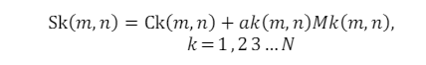Based on the embedding algorithm, the value of k is changed. The hiding capacity of the embedding algorithm depends on the number of bits (k) that can be manipulated in the cover video. Increasing the number of bits for hiding can increase the hiding capacity but will overburden the carrier leading to the exposure of the secret data. But in the case of video, the steganography sender sends the confidential message to the recipient via the video sequence. The optional “k” can also be used when embedding the confidential message in the cover media to produce a “stego-video”. The stego video is then transmitted to the receiver via the common channel. At the receiving end, the receiver uses the secret key in conjunction with the extraction algorithm to extract confidential information from the stego object. The original cover video consists of frames represented by the total number of frames, Ck (m, n), and m, n are the row and column indexes of the pixels, respectively. The binary secret message indicated by mk (m, n) is modulated into a signal and the cover is embedded in the video medium. Mk (m, n) is defined in the same domain as host Ck (m, n). The equation represents the stego-video signal as ak(m, n) is a scaling factor.

**Figure 2.1: Equation for Stega-Video Signal**

To make it simple, it can be considered constant at all the pixels. Video steganography measures imperceptibility, burden, security, statistical attacks, cost of computation and perceptual quality. (B. Chandel, and S. Jain) [17]. One of the well-known steganographic methods is the least significant bit (LSB) substitution (C.H. Yang, C.Y. Weng, S.J. Wang, H.M. Sun, (2008) [18].

Steganography application hides info by reinstating only the least significant bits (LSB) of an image with the bits in the file to be concealed. Figure 2.2 shows an example of the bit substitution.

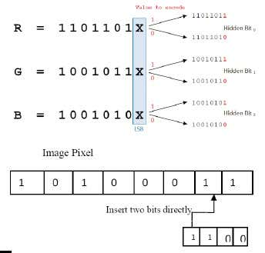

**Figure 2.2: Example of Least Bit Substitution and its Explanation**

The idea is to store the information in the first bit of the colour (RGB) component of each pixel. In the worst case, the decimal value is different from a value not seen by the human eye. In practice, it should start using the second bit, even if it will store all data in the first bit of each pixel. The higher the repository data in an image, the more it will be detected. (R. Kaur, and Pooja,2016) [19]

## **2.3.2 Advanced Encryption Standard (AES)**

The Advanced Encryption Standard (AES) is a symmetric block cypher algorithm that has become the de facto standard by encrypting and decrypting information, effectively protecting electronic data and secure data encryption worldwide. It is recognized for its exceptional characteristics in terms of security, efficiency, and flexibility compared to other symmetric-key cryptographic algorithms such as Data Encryption Standard (DES). Daemen, J. & Rijmen, Vincent. (2002) [20].

To elaborate, it operates on a block cypher principle, where data is divided into blocks and encrypted separately. The algorithm supports multiple key lengths - 128, 192, and 256 bits thus offering flexibility and strong security against brute-force attacks. (Rao, S., Mahto, D., & Khan, D. (2017)) [21] Its mathematical structure is based on the 'Rijndael' algorithm, selected for its simplicity, efficiency, and ability to resist known cryptographic attacks (Paar & Pelzl, 2010) [22]. The AES algorithm can be implemented in a variety of platform languages, including C, Matlab, and Java.

|  |  |  |  |
| --- | --- | --- | --- |
| **AES Key Size** | **Key Length (words)** | **Block Size (words)** | **Number of rounds** |
| **128-bit** | 4 | 4 | 10 |
| **192-bit** | 6 | 4 | 12 |
| **256-bit** | 8 | 4 | 14 |

**Table 2.3: AES Key Size with Key length, Block Size and Number of Rounds (Deshpande et al., 2014)**

## **2.3.3 Peak Signal-to-Noise Reduction (PSNR)**

Recent advancements in steganography, especially in video and image domains, have seen significant improvements in both embedding capacity and quality preservation, as evidenced by various studies focusing on the Least Significant Bit (LSB) method. In the realm of video steganography, (Shwe Sin Myat Than's. (2020)) [23] research demonstrated the superior performance of combining LSB with Huffman chunk coding, achieving higher Peak Signal-to-Noise Ratio (PSNR) values, a critical indicator of quality retention in steganographic practices. Similarly, (Haeyoung Lee. (2018)) [24] presented an adaptive LSB method tailored for spatial colour images on smartphones, which not only offered a high capacity of 8.4 bits per pixel (bpp) but also maintained an average PSNR of 43.7db, underscoring the method's efficacy in preserving image quality. Such findings underscore the potential of advanced LSB techniques in enhancing steganographic quality and capacity. Further enhancements in LSB steganography have been explored in various studies. (Gandharba Swain. (2016)) [25] introduced a novel approach by combining LSB substitution with pixel value differencing within a block, showing notable improvements in both hiding capacity and PSNR in the context of video steganography.

This method's balance between imperceptibility and payload capacity marks a significant stride in steganographic technique development. Additionally, research by (P. Malathi & T. Gireesh Kumar. (2016)) [26] on image steganography using LSB techniques with matrix embedding yielded better results in terms of Mean Squared Error (MSE) and PSNR. Although focused on image steganography, these findings offer valuable insights that can be extrapolated to video steganography, given the similar underlying principles.

## **2.3.4 Reed-Solomon Coding**

The development and refinement of steganographic techniques using LSB (Least Significant Bit) methods, especially in the context of video and image data, have been the subject of extensive research. A significant advancement in this field is the integration of Reed-Solomon coding for enhanced security and robustness of the hidden data. Assurance, (Bhattacharyya, D., Bhaumik, A.K., Choi, M., Kim, Th. (2010) (2010)) [27] introduced a novel approach termed Directed Graph Pattern Synthesis in the LSB Technique. This method notably utilizes Reed-Solomon coding for data hiding in video streams, thereby not only bolstering the security of the embedded data but also its resilience against potential distortions during transmission and compression. Similarly, (Diop, Farssi, Khouma, and Diouf (2012)) [28] explored the Matrix Embedding Using the Reed-Solomon Codes technique. This method adeptly addresses the challenges associated with bounded syndrome decoding in video steganography. By optimizing the efficiency of embedding secret data into videos, this approach stands out in enhancing the capacity and security of steganographic practices in digital media. Further expanding upon these methodologies, (Xu (2022)) [29] proposed an Improved LSB Algorithm Based on RS-Code. This algorithm is particularly noteworthy for its heightened immunity against various steganalysis attacks while simultaneously maintaining a balance between imperceptibility and data capacity. Its ability to facilitate the self-correction of encrypted images marks a significant step forward in the practical application of steganography for secure data transmission.

On another front, (Banerjee & Jana (2019)) [30] introduced a Reversible Data Hiding Scheme that ingeniously uses Reed-Solomon codes to embed secret data within additional pixels in a block. This method ensures exact image quality preservation, a key factor in maintaining the integrity of the original data, while also enhancing the robustness of the embedded information.

In a similar vein, (Shi Rui (2005)) [31] demonstrated how combining Reed-Solomon codes with an improved LSB embed algorithm can achieve High Watermark Robustness in Image Embedding. This approach particularly stands out for its application in digital watermarking, offering a robust solution for protecting copyrights and intellectual property in digital imagery. Each of these studies contributes to a deeper understanding and improvement of steganographic practices, particularly highlighting the versatile applications of Reed-Solomon coding in securing and preserving data integrity in digital media.

# **2.4 Review of Related Products**

This review briefly introduces the existing products and tools designed for video steganography using the Least Significant Bit (LSB) technique. We examine various related products, assessing their capabilities, user interfaces, and its effectiveness.

## **2.4.1 OpenPuff**

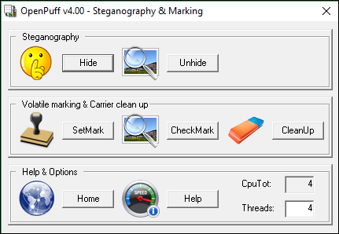[32] OpenPuff is a software tool that offers advanced steganography capabilities, including video steganography using the Least Significant Bit (LSB) technique. In the context of video steganography, OpenPuff enables users to select specific frames and audio samples within video files to hide information. The LSB technique is utilized to subtly alter the least significant bits of the selected frames without causing noticeable changes to the video's appearance. OpenPuff also supports message fragmentation and random data insertion to enhance the security and complexity of hidden information. Users can access a user-friendly graphical interface to configure various steganography parameters, ensuring a seamless embedding process. OpenPuff's compatibility with multiple file formats and its focus on security make it a comprehensive tool for individuals seeking robust video steganography solutions using OpenPuff, you can select any type of carrier such as image, audio, flash and of course video (3GP, MP4, MPG and VOB) to encrypt hidden data in it.OpenPuff also includes some popular encryption techniques to encrypt secret files in a video. It offers 256+256-bit symmetric key, 256-bit symmetric key data scrambling, and 256-bit symmetric key data whitening-like encryption techniques. Figure 2.3 shows the homepage for OpenPuff.

**Figure 2.3: Interface for OpenPuff**

The next interface is divided into 4 sections for performing tasks, with the first section setting the desired password for unhiding the data.

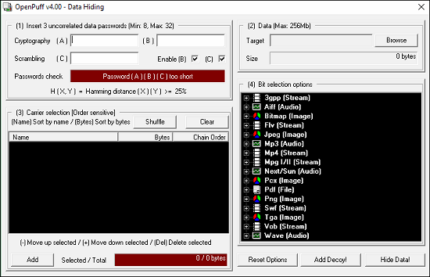

**Figure 2.4: Interface on selecting Data for Hiding**

The second section is the carrier section, which provides the selected carrier video file for hiding messages/documents. It can also select multiple carrier video files to hide the data in it.

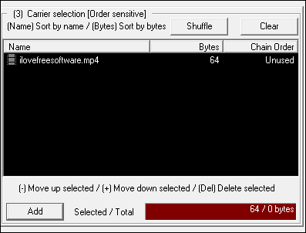

**Figure 2.5: Interface for Carrier Selection**

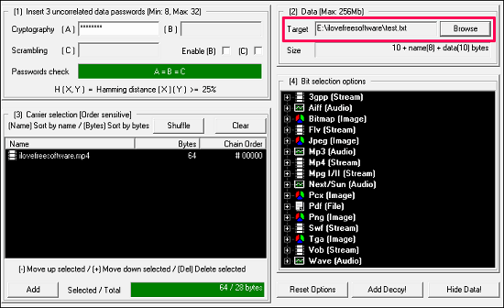

**Figure: 2.6: Interface for embedding hidden data**

To hide the target file into a carrier video file, simply click *Hide Button* to complete the process.

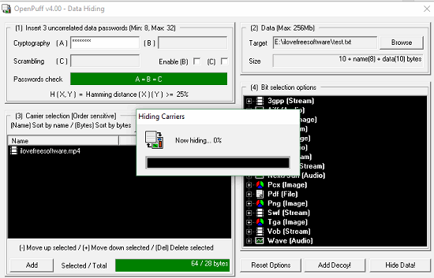

**Figure 2.7: The process of hiding carriers**

## **2.4.2 Our Secret**

Our Secret is another freeware that you can use to hide messages and documents in videos. It has a very simple interface, and hiding, and unhiding can be done from the same window. It has numerous features that make it different from other video Steganography software. One of the best features of Our Secret is that you can hide multiple messages or documents in a single video file.

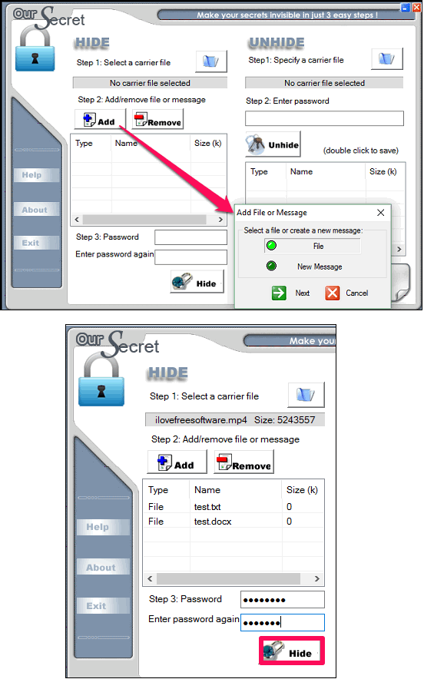

**Figure 2.8: Our Secret – Add Files or Messages**



**Figure 2.9: Our Secret – Enter the Password to Hide Messages**

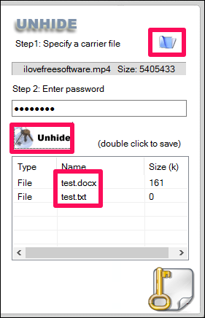

**Figure 2.10: Our Secret – Steps to Unhide**

One of the biggest advantages of **Our Secret**is that to hide a message in a video file, it provides an option on its interface to type a message and add a subject to that without attaching a Text or Word file.

## **2.4.3 StegoStick**

StegoStick is another powerful video Steganography software to hide messages and documents. It has a very polished user interface. It does what it promises and the best thing about this freeware is that it provides 4 different encryption techniques to embed secret files in a carrier file. The encryption techniques that it has: are DES, Triple DES, RSA, and default. If you encrypt your secret file with RSA encryption, then it is nearly impossible to decrypt it without the actual key.

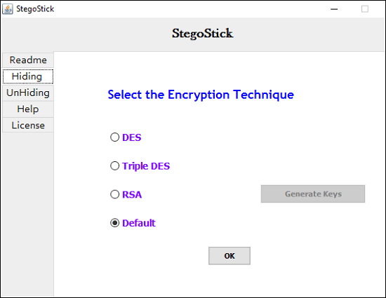

**Figure 2.11: StegoStick Interface**

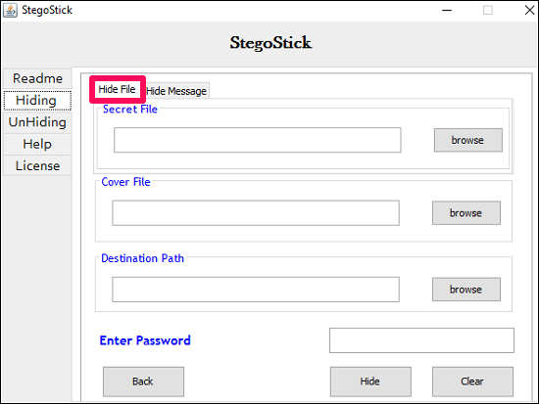

**Figure 2.12: StegoStick – Hide File**

**2.5 Comparison between Related Products**

|  |  |  |  |
| --- | --- | --- | --- |
| **Feature** | **OpenPuff** | **Our Secret** | **StegoStick** |
| **Platform** | Windows, Linux | Windows, Linux | Windows, Linux |
| **Steganography Method** | Multi-format | Images and Text | Images |
| **File Types** | Any (audio, video, documents) | Images and Text Files | Images |
| **Additional Features** | Portable Version Available | Steganalysis Tools Included | Steganalysis Tools Included |
| **Data Capacity** | High | Moderate To High | Moderate |
| **Open Source** | Yes | No | Yes |

**Figure 2.2: Comparison of related products**

The table compares various features of three steganography products—OpenPuff, Our Secret, and StegoStick. All three products are compatible with Windows and Linux, with OpenPuff supporting a multi-format steganography method for diverse file types, including audio, video, and documents. Our Secret hides data within images and text files, while StegoStick primarily focuses on image steganography.

OpenPuff stands out for offering a portable version. Our Secret includes steganalysis tools for detection, and StegoStick provides steganalysis tools for potential hidden data analysis. In terms of data capacity, OpenPuff excels with high capacity, Our Secret offers a moderate to high range, and StegoStick provides a moderate capacity. OpenPuff and StegoStick are open source, allowing user modifications, while Our Secret is closed source. This comprehensive comparison assists users in selecting a steganography tool based on specific preferences and requirements, considering platform compatibility, steganography methods, supported file types, additional features, data capacity, and the preference for open or closed-source software. Each product caters to distinct use cases and user preferences. [33]

# **CHAPTER III**

# **RESEARCH DESIGN AND METHODOLOGY**

**3.1 INTRODUCTION**

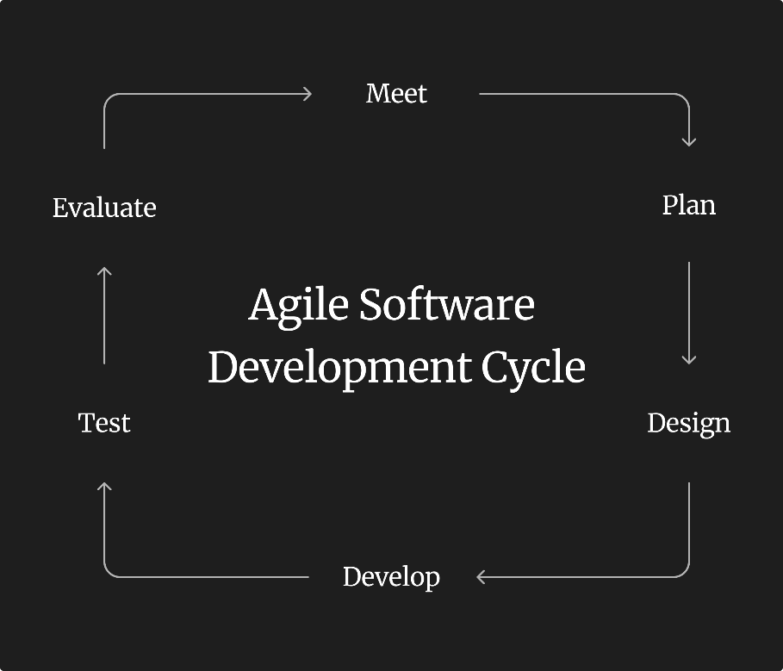The methodology for this project revolves around six crucial steps and aims to achieve a balance between imperceptibility, robustness, and payload capacity, and can be further optimized based on specific requirements and constraints of the project involved. One of the first steps includes Frame Selection, which involves selecting appropriate video frames for steganography. The video selection filtering criteria may be based on frame type, frame rate and content complexity. Next, the LSB (Least Significant Bits) to be replaced with hidden information is determined. This can be based on the analysis of the video file, taking into account factors such as video quality, visual perception, and robustness requirements. The LSB technique is applied to embed the hidden messages in the selected frames by replacing the LSBs with the corresponding bits of the hidden data. The modifications do not significantly affect the visual quality of the video file if extra care and monitoring are involved. Optionally, one of the extra steps can be the hidden information encrypted using a suitable encryption algorithm to further enhance the security of the stego-video. Finally, the hidden information is extracted from the stego-video using the same LSB technique and decryption (if applied), and the extracted data is compared each other with the original hidden data to ensure the accuracy of the extraction process.

**Figure 3.1**: **Agile methodology development cycle**

# **3.2 Development Methodology**

The development methodology used as shown in Figure 3.1 is the Agile development approach, which emphasizes iterative and incremental development.

Here’s the development methodology for video steganography with LSB techniques:

Meet: Gather your team to discuss the project's goals, challenges specific to video steganography, and the use of LSB for data embedding.

Plan: Outline the project scope, define timelines, and organize sprints. Choose the necessary tools and software, and establish the initial approach for implementing the steganography algorithm.

Design: Create a detailed design on the steganography system. Specify how LSB will be used to hide data within videos, outline the data encoding and decoding processes, and design the user interface if applicable.

Develop: Begin the coding process of the steganography system according to the design plan. Implement and outline the LSB technique.

Test: Conduct rigorous testing to evaluate the system's functionality and security. Assess the effectiveness of data hiding and the system's resistance to steganalysis techniques.

Evaluate: Review the test results with the stakeholders involved to assess the system's performance. Discuss any feedback or issues that emerged during testing and make necessary refinements.

# **3.3 Hardware and Software Requirements**

The hardware and software configurations of the system on which it is installed for the projects are imminent to ensure smooth operation and processing performance for the application. Here are some of the breakdowns for hardware used such as a computer with sufficient processor, RAM, storage, and screen display capabilities. To effectively manage the computational demands of video processing and data embedding and extraction tasks, an effective multi-core processor is recommended for usage. To handle the big video files and the processing activities, there must be recommended basic RAM sizes, often 4 GB or more.

Adequate device storage space is needed to store the video files, the application software, and any additional data. Additionally, for users to read and interact with the UI/UX successfully, a monitor or screen device with the right resolution is recommended.

Next, the software requirements, compasses operating system, development environment, libraries or frameworks, and other tools required for the video steganography system are all included and recommended in the list of software requirements. Popular operating systems like Windows, macOS, or Linux can also be compatible with the system. The system developed and implemented properly recommended to be paired with the appropriate tools and frameworks, such as an integrated development environment (IDE) and video processing cryptography libraries such as OpenCV, PyQt5, NumPy, and PyTesseract. The project requirements and the development environment should also be taken into consideration while selecting a programming language (such as Python or Java) to code the system’s backend. If encryption is required for the embedded data, encryption libraries and user interface libraries are also crucial elements for the encryption process.

# **3.4 Project Schedule**

Project Initiation (1 week):

- Define project objectives and scope

- Identify stakeholders and project team members

- Conduct initial research and feasibility analysis

Requirements Gathering (2 weeks):

* Define functional and non-functional requirements
* Gather user requirements and system specifications
* Conduct user interviews or surveys

System Design (2 weeks):

* Design the system architecture
* Define the data structures and algorithms for LSB-based steganography
* Create wireframes or mockups for the user interface

System Development (8 weeks):

* Implement the LSB steganography algorithm
* Develop the user interface and backend functionalities
* Perform unit testing and bug-fixing

Integration and Testing (4 weeks):

* Integrate the different components of the system
* Perform system testing and validation
* Identify and resolve any integration issues

Documentation and User Training (1 week):

* Create user manuals and system documentation
* Conduct user training sessions or workshops
* Prepare technical documentation for future maintenance

Deployment and Launch (1 week):

* Prepare the system for deployment
* Conduct final testing in the production environment
* Launch the video steganography system

# **3.5 UML (Unified Modelling Language) Diagram**

Unified Modeling Language (UML) is a standardized, visual modelling language designed for expressing, designing, and documenting software systems and their components. It provides a set of graphical notations that facilitate the representation of various aspects of software architecture, structure, behaviour, and interactions among system components. UML serves as a common language for software developers, designers, and stakeholders, enabling effective communication and understanding of complex software systems throughout the software development life cycle. With its standardized diagrams and symbols, UML promotes consistency and clarity in the visualization and documentation of software designs, making it a valuable tool in the field of software engineering.

**Use Case Diagram**

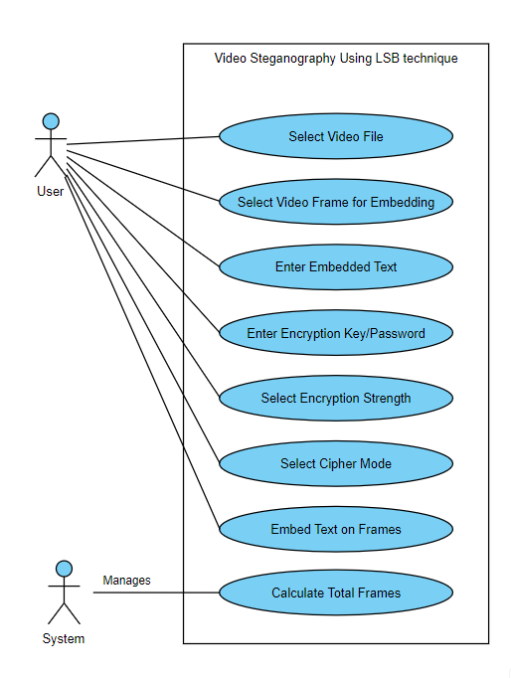

**Figure 3.2: Use Case Diagram**

In the context of the video steganography application, the actors and use cases outlined in the figure above are the basis of a use case diagram. The "User" is the primary actor, representing the individual interacting with the application. The main use cases are designed to capture key functionalities provided to the user during the steganography process. The "Select Video File" use case allows the user to choose a video file as the target for steganography, initiating the process. The "Calculate Total Frames" use case assists the user by determining and displaying the total number of frames in the selected video, providing crucial information for subsequent actions. "Select Frames for Embedding" allows users to specify particular frames where text will be embedded, providing a customized approach to steganography." Enter Embedded Text" is a use case where users input the text to embed into the video frames.

The "Select Output Video File" use case permits users to designate the path for the steganography result, ensuring flexibility in the output location. "Enter Encryption Key/Password" enables users to enhance the security of the embedded text by entering a key or password.

The subsequent "Select Encryption Strength" use case empowers users to choose between two encryption strengths, AES-128 or AES-256."Select Cipher Mode" provides users with the option to select a specific cipher mode, either CBC (Cipher Block Chaining) or GCM (Galois/Counter Mode), further customizing the steganography process.

Finally, the "Embed Text on Frames" use case serves as the primary trigger for initiating the process of embedding text into the selected frames. The included relationship between "Embed Text on Frames" and "Calculate Total Frames" signifies that the latter is an essential step included in the embedding process.

In contrast, the extended relationship suggests that the "Embed Text on Frames" use case may extend to include additional functionality or handle errors as necessary, providing a modular and extensible design for the steganography application.

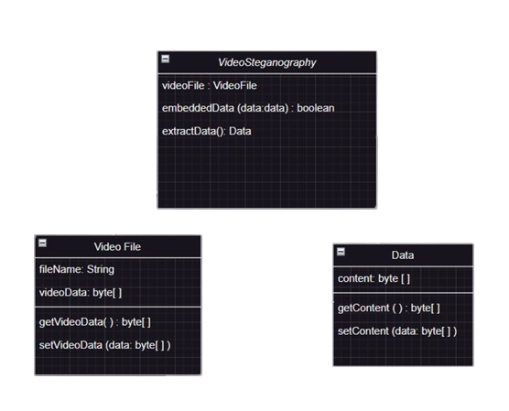**Class Diagram**

**Figure 3.3 Class Diagram**

A Class Diagram is a visual representation of the classes, their attributes, methods, and relationships within a system. The Class Diagram above illustrates the interactions and relationships between classes in the context of video steganography using the LSB technique. The ‘VideoSteganography’ class acts as the central controller, initiating the encoding and decoding processes by embedding data during the encoding process and extracting data during the decoding process. It collaborates with the ‘Video File’ class, which stores video frames or ‘videoData’, and the ‘Data’ class, which handles the embedding and extraction of hidden data using LSB manipulation.

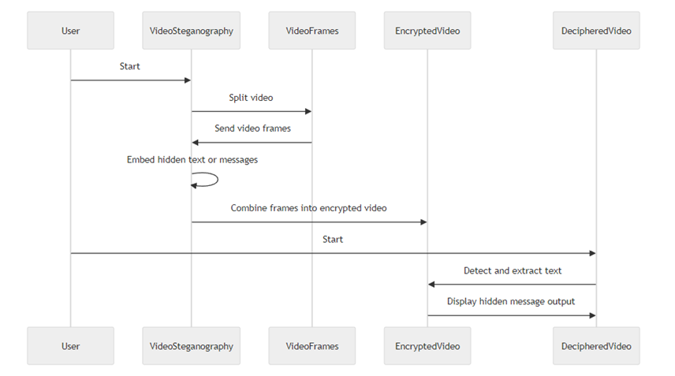

**Figure 3.4 Sequence Diagram**

A Sequence Diagram illustrates the interactions in video steganography using the LSB technique. The User initiates “upload video” and it runs with two primary algorithms which are: "Encoding Software" and "Decoding Software." During the process of encoding, the user provides an external video source and specifies the data to be concealed. The system then processes the video frames, modifying the LSBs of pixel values according to the hidden data. The system then generates a stego-video file containing the concealed information. Similarly, the user can decode hidden data from a stego-video using the "Decoding Software".

Here, the system analyzes the stego-video to retrieve the concealed data and present it to the user.

This diagram encapsulates the core functionalities, depicting the user's role, external input, and the system's interactions, facilitating comprehension of video steganography's LSB-based processes.

Explanation of Actors:

User: The person initiating the video steganography process.

System: The steganography system is responsible for encoding and decoding hidden data within videos.

External Video Source: The input video file provided by the user for the encoding process.

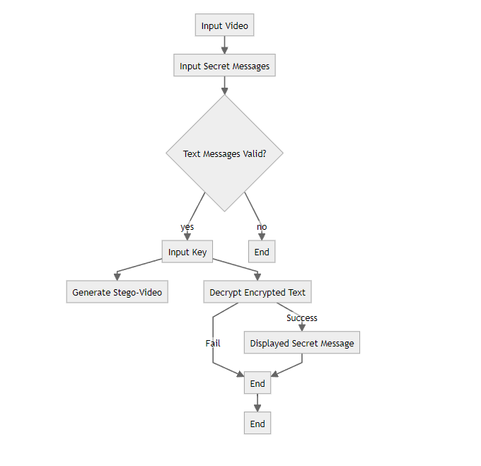

**Figure 3.5 Activity Diagram**

An Activity Diagram is a graphical representation of a system’s workflow, showing the sequence of activities or actions that need to be performed in a process. In the Activity Diagram for Video Steganography, the process begins with the “Input Video” activity, where the user chooses a digital video as the carrier for hidden data.Subsequently, the user “Input Secret Messages” is to be concealed within the video frames. If the text messages show valid, the process then proceeds to “Input Key,”

where users may select the output folder and encrypt the specified data within the video. Following successful embedding, the system then “Generate Stego-Video,” which is the video with the hidden data. Optionally, the user can choose to “Decrypt Encrypted Text” from a stego-video if the input key or password matches, and if successful, the extracted data is “Displayed Secret Message.” Finally, the process concludes. This Activity Diagram illustrates the sequence of steps involved in video steganography, from data selection and embedding to optional extraction, aiding in understanding the workflow of this technique.

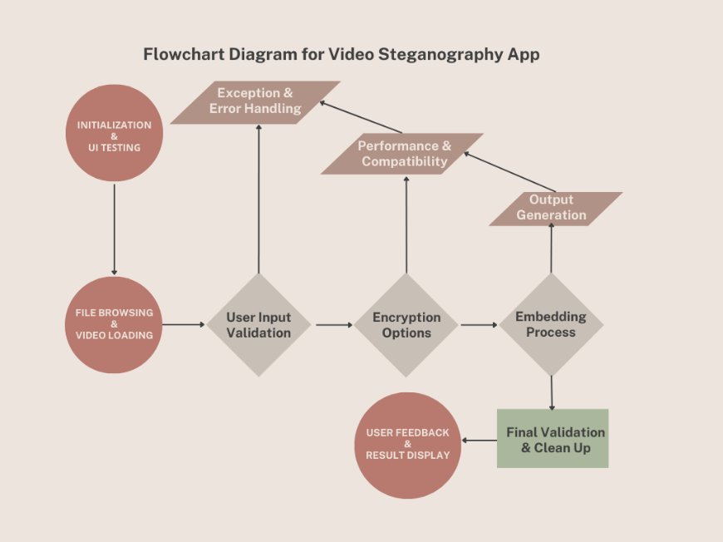

**Figure 3.6 Flowchart Diagram for Video Steganography App**

This flowchart outlines the process flow for a Video Steganography App, which begins with Initialization and UI Testing, ensuring the app is ready for user interaction. Following this, the user can browse and load a video file, with user input being validated to ensure correct data entry. If errors occur, Exception and Error Handling takes place.

Next, the user is presented with Encryption Options to secure the data before the Embedding Process, where the data is concealed within the video. The process then assesses Performance and compatibility to ensure the app works efficiently across different platforms or video formats, leading to Output Generation. The user receives the steganographed video, provides Feedback, and sees the Result Display. Finally, the app undergoes Final Validation & Clean Up to ensure that the output is accurate and all temporary data or processes are terminated properly.

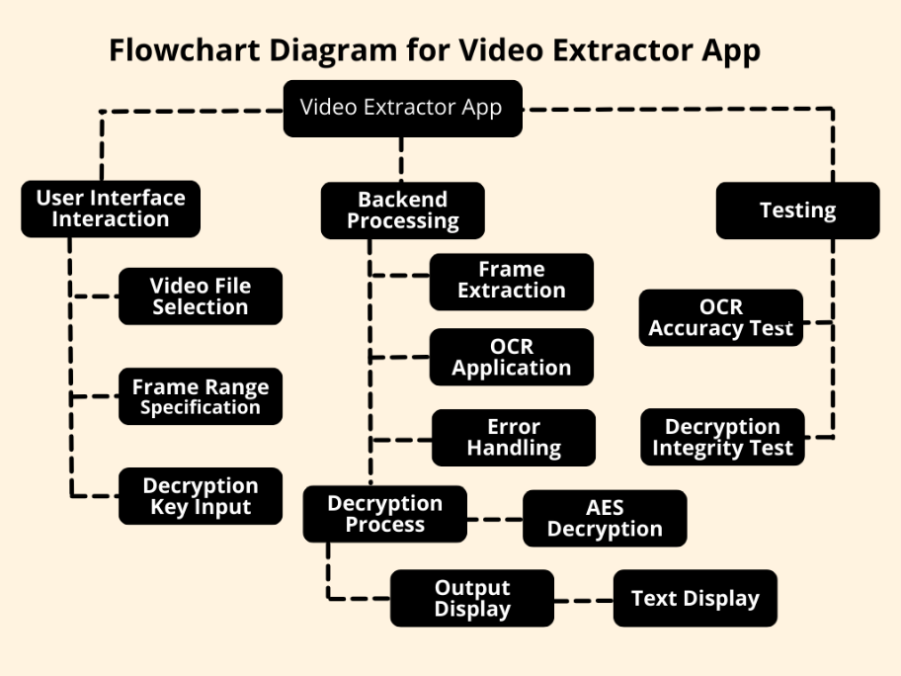

**Figure 3.7 Flowchart Diagram for Video Extractor App**

The following flowchart illustrates the operational process of a Video Extractor App, which is often for extracting and decrypting text after embedding and encrypting text on the Video Steganography App, the system is divided into three main segments: User Interface Interaction, Backend Processing, and Testing. In the User Interface Interaction phase, the user selects a video file, specifies a range of frames, and inputs a decryption key.

The Backend Processing phase begins with extracting frames from the video, applying Optical Character Recognition (OCR) to convert any text within the frames into a machine-readable format, and includes error handling for any issues that arise. The decryption process, specifically using AES (Advanced Encryption Standard) decryption, is then applied presumably to the text extracted.

Finally, the Testing phase ensures the app's performance through an OCR Accuracy Test and a Decryption Integrity Test to verify the correctness and integrity of the text extraction and decryption processes. The output, which is the decrypted text, is then displayed to the user.

# **3.6 User Interface Design (UI/UX)**

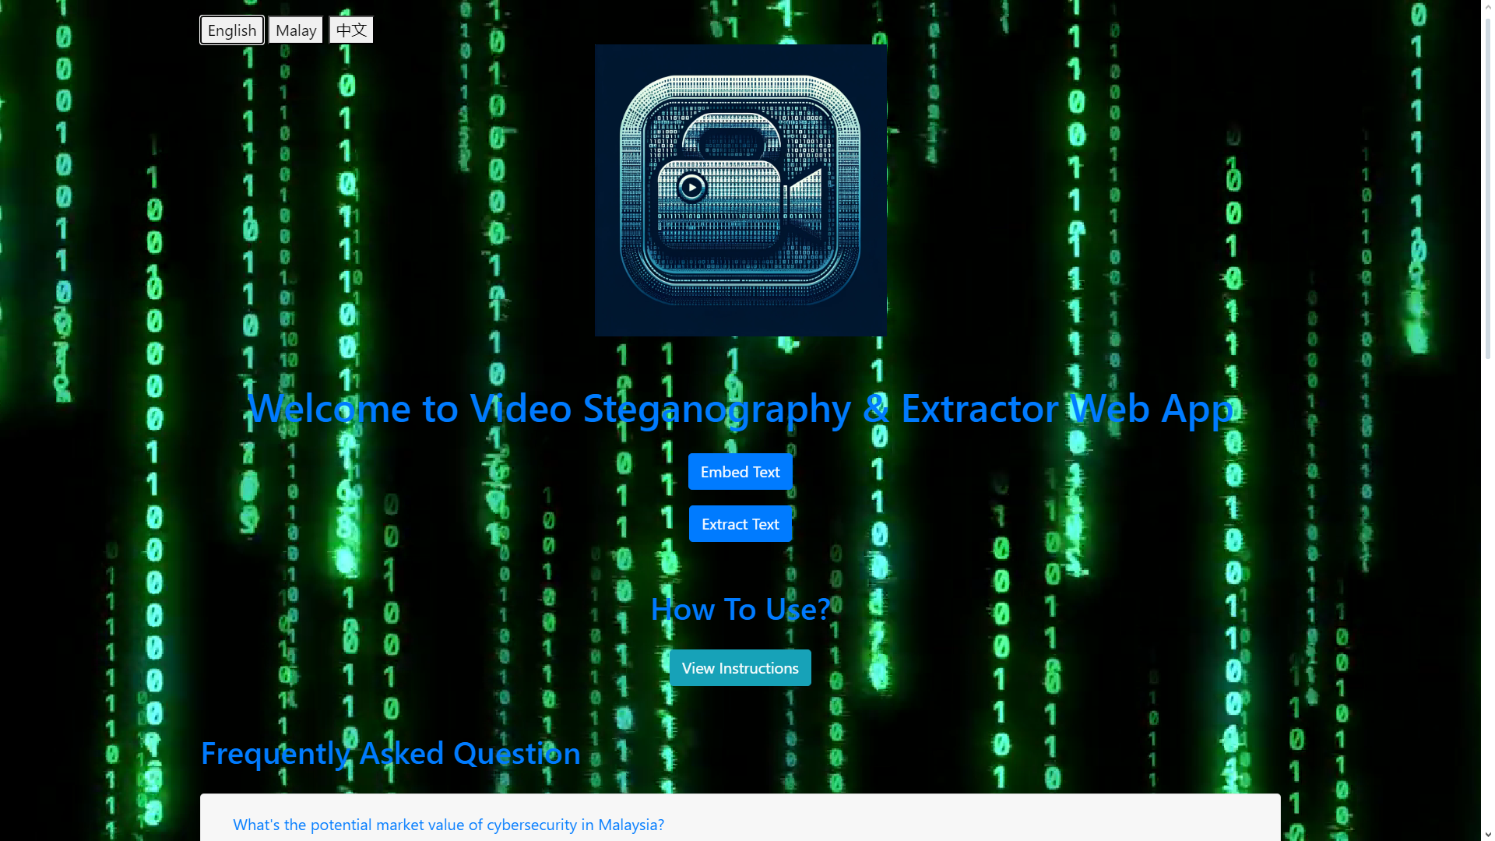

**Figure 3.8: Web application main page**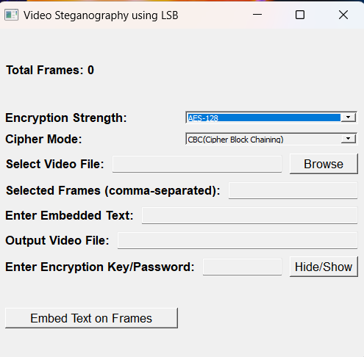

**Figure 3.9: Video Steganography – User Interface**

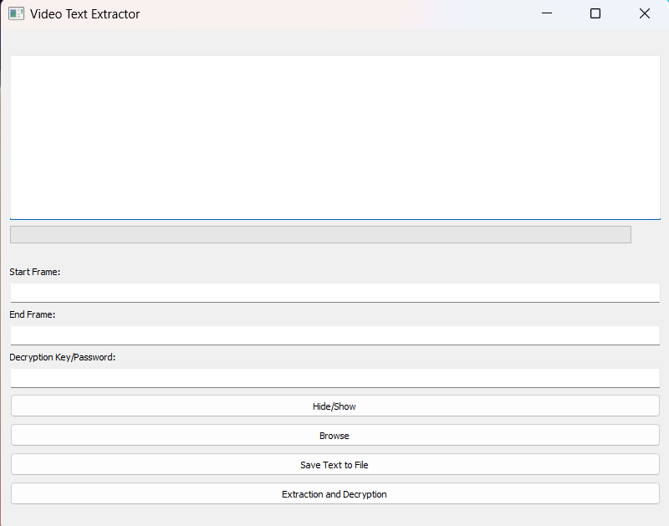

**Figure 3.10: Video Text Extractor – User Interface**

Figure 3.8 shows a user interface for a web app that provides video steganography and extraction features which lets users hide or reveal text in videos using video steganography. The user-friendly interface allows users to upload, modify, and download videos with embedded or extracted text. It also has a FAQ section that provides information about video steganography and cybersecurity. The webpage has a cyber-themed design GIF with a matrix-style binary code animation in the background and supports multiple languages.

Figure 3.9 shows the embedding text feature which is a part of a software interface for video steganography using LSB (Least Significant Bit). In technical terms, this feature allows any user to embed hidden text within video frames without noticeable alterations to the video quality. Users can select a specific video file and choose particular frames (comma-separated) to embed the text. The embedded text is encrypted with an AES-128 or AES-256 encryption strength and CBC (Cipher Block Chaining) and GCM (Galois/Counter Mode) mode for enhanced security. Users may enter the encryption key/password to secure the embedded text, ensuring it can only be accessed or decrypted by authorized individuals.

Lastly, Figure 3.10 shows the user interface for the text extractor app to extract and decrypt text from videos, possibly encrypted ones. The user can browse files, specify the start and end frames of the video, and enter a decryption key or password. The extracted text can be saved to a file or displayed on the screen. This is a tool that can be useful for analysing video content or recovering hidden messages.

# **3.7 Summary**

In summary, in this concise overview, a meticulous six-step approach is outlined to optimize the effectiveness of video steganography employing the Least Significant Bit (LSB) technique. The methodology strives to strike a balance between imperceptibility, robustness, and payload capacity, allowing for customization based on specific project requirements and constraints. The initial steps involve Frame Selection, where video frames are carefully chosen based on criteria such as frame type, frame rate, and content complexity. Subsequently, the LSBs to be replaced with hidden information are determined through an analysis considering video quality, visual perception, and robustness requirements. The LSB technique is then applied to embed hidden messages in selected frames, ensuring minimal impact on visual quality. Optionally, encryption using a suitable algorithm can further enhance the security of the stego-video. The final step involves extracting hidden information using the same LSB technique and decryption (if applied), with a rigorous comparison to the original hidden data to ensure extraction accuracy. The development methodology follows an agile approach, emphasizing iterative and incremental development. The agile cycle involves key stages such as meeting to discuss project goals, planning to define scope and timelines, designing the system architecture, developing the steganography system, testing its functionality and security, evaluating performance with stakeholders, and finally, documenting and launching the system.

This iterative methodology provides flexibility and adaptability throughout the development process, ensuring continuous refinement and responsiveness to evolving project needs. Additionally, the hardware and software requirements, project schedule, UML diagrams (including Use Case, Class, Sequence, and Activity diagrams), and a flowchart are comprehensively presented, providing a holistic view of the research design and methodology. The user interface design for a web application offering video steganography and text extraction features is also depicted, showcasing an intuitive and cyber-themed interface for a seamless user experience.

# **CHAPTER IV**

# **RESULTS AND DISCUSSIONS**

# **4.1 Introduction**

In this chapter, we introduce two prototype applications that showcase the advancements in digital security and information processing: the Video Steganography Application (VideoSteganographyApp) and the Video Text Extractor Application. The VideoSteganographyApp allows for encrypted text to be hidden within video frames, while the VideoTextExtractor can be used to extract and decrypt this concealed text. We will also discuss the research conducted and the production process of these end-products, along with various tests performed to measure the quality of the output video in comparison to previous research.

# **4.2 Testing Approach & Environment**

To evaluate the performance of a video steganography application using the Least Significant Bit (LSB) insertion method and to compare the processing times of different encryption methods across various video resolutions. The proposed testing approach was to provide options for encryption strength, cipher mode, file selection, frame selection, and embedded text. By putting three video sequences of multiple variables, such as utilizing 480, 720p, and 1080p video formats. The approach of the testing is through inspecting and comparing the original video and embedded hidden text of the stego-video. While the test cases are as follows:

**Test Case 1: Embed text into a 480p video file within a selected video frame using LSB with AES-256 and CBC cipher mode**

**Test Case 2: Embed text into a 720p video file within a selected video frame using LSB with AES-128 and GWM cipher mode**

**Test Case 3: Embed text ‘NewJeans’ into a 1080p video file using LSB with AES-128 and CBC cipher mode**

**Test Case 4: Measure processing time for each resolution using AES-256 with CBC mode.**

# **4.3 Results**

For test case 1, the hidden text is embedded into the selected frames of the video file using the mentioned encryption which is AES-256 and cipher mode which is CBC. The video processing library’s logs are monitored to ensure the stega video and audio are being processed correctly. The figure below shows the processing log and video processing interface along with the test results.

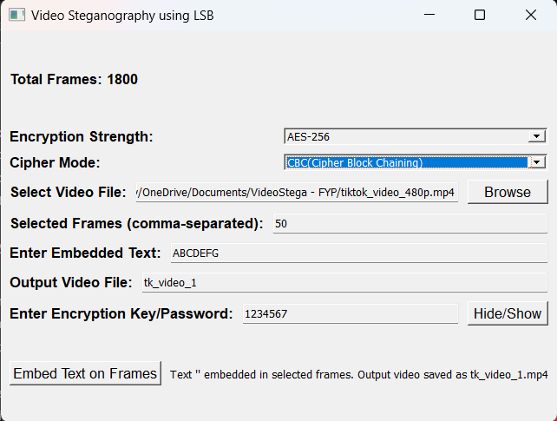

**Figure 4.1 Video Steganography Interface with Test Results for 480p Video File**

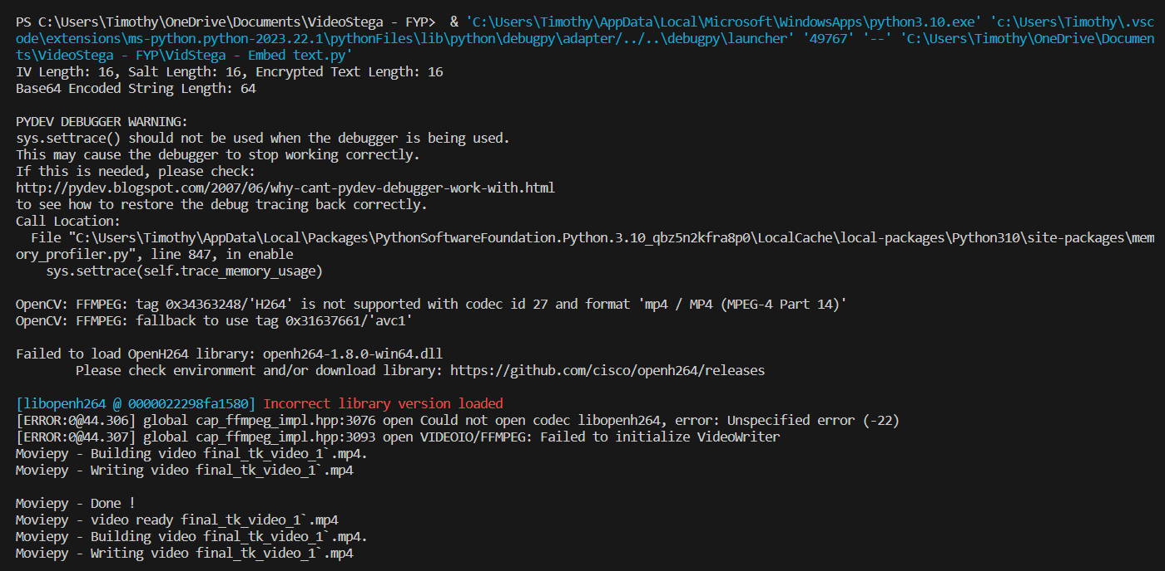

**Figure 4.2 Video Processing Log with Final Test Results for 480p Video File using MoviePy**

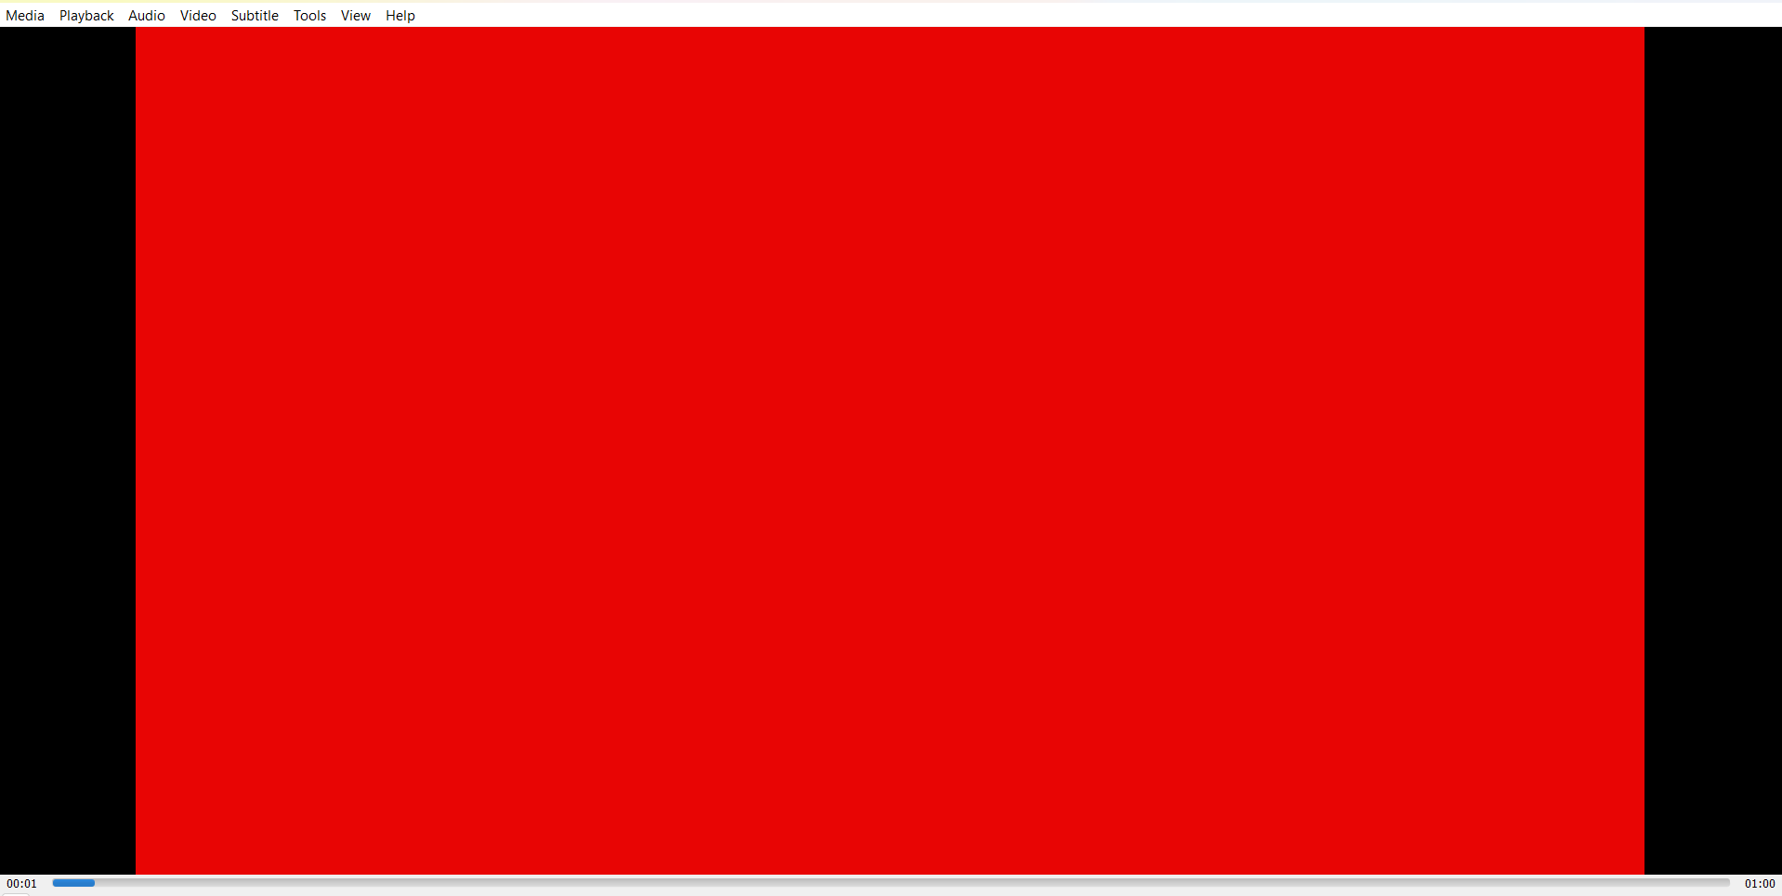

**Figure 4.3: Original 480p Video**

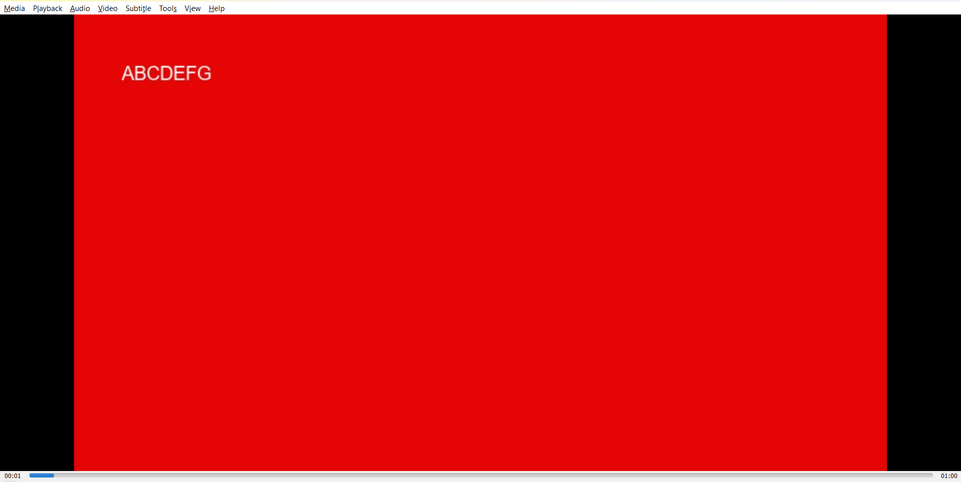

**Figure 4.4: Stego-Video for 480p**

Figure 4.2 shows the processing log results that the IV length, Salt length and Encrypt Text Length are 16 bits each. Meanwhile, MoviePy will process another Final Stega-video file to be paired with a complete audio file as same as the original video format.

Figure 4.3 and Figure 4.4 show the difference between embedded hidden text and after-embedded hidden text on the selected video frame as entered in Figure 4.1.

To conclude, test case 1 shows the test results are successful and the embedding hidden text feature is working.

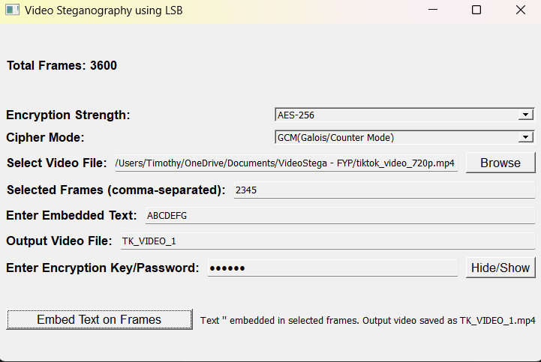

**Figure 4.5 Video Steganography Interface with Test Results for 720p Video File**

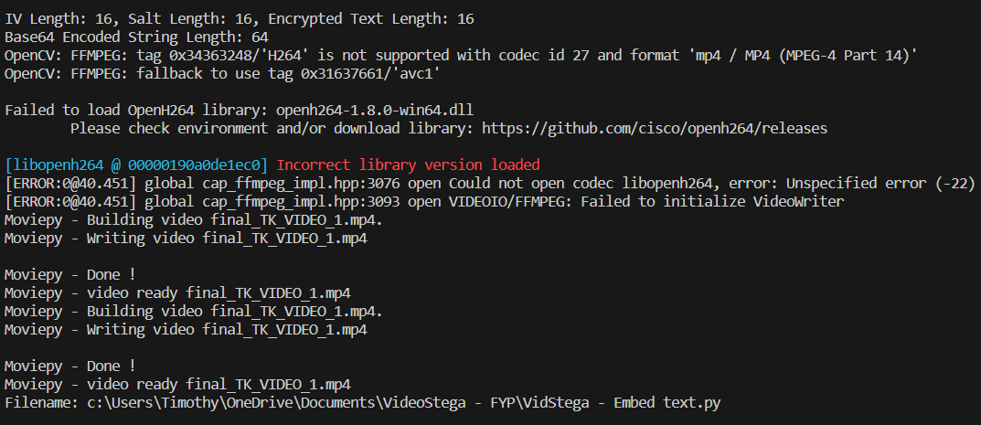

**Figure 4.6 Video Processing Log with Final Test Results for 720p Video File using MoviePy**

For test case 2, the hidden text is embedded into the selected frames of the video file using the mentioned encryption which is AES-128 and cipher mode which is GWM. The video processing library’s logs are monitored to ensure the final video and audio are being processed correctly and no compromise on video quality. Figure 4.7 and Figure 4.8 show the main difference on original video and Stega-video before and after embedding hidden text.

The process log provided by the video processing library validated the successful embedding of the text "test" into the video, culminating in the generation of a new video file with the embedded data intact.

In summary, the feature of embedding hidden text within a 720p resolution video file is successfully tested and working.

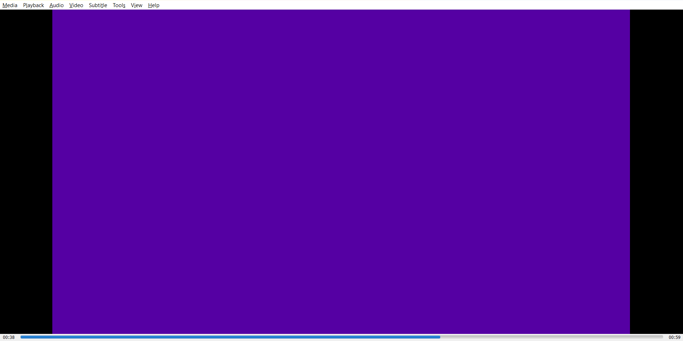

**Figure 4.7: Original 720p video**

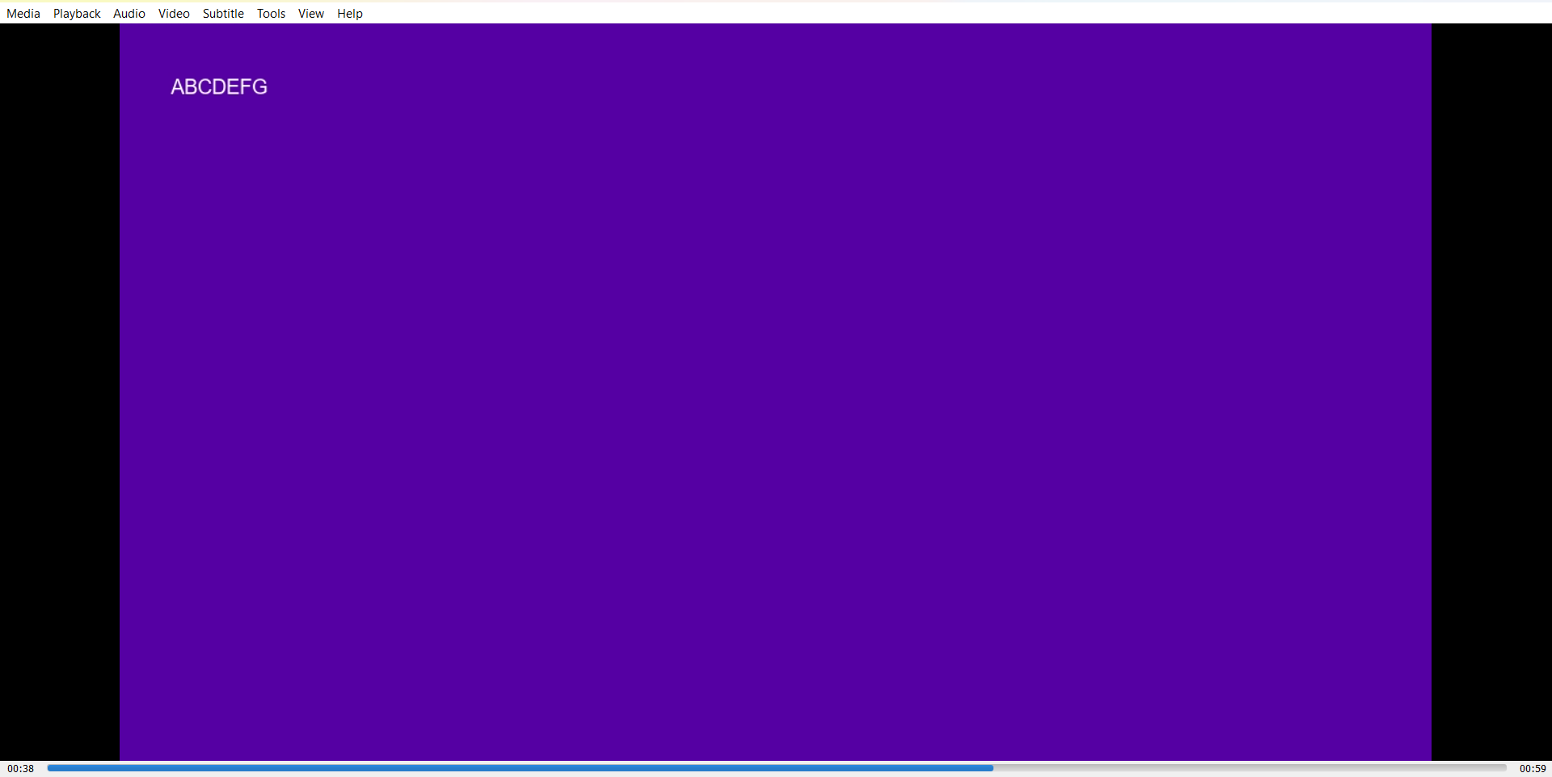

**Figure 4.8: Stego-Video for 720p**

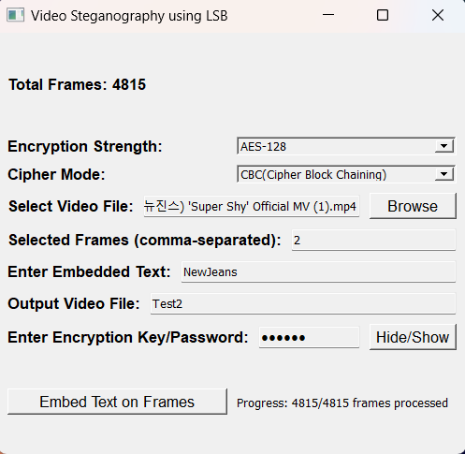

**Figure: 4.9: Video Steganography Interface with Test Results for 1080p Video File**

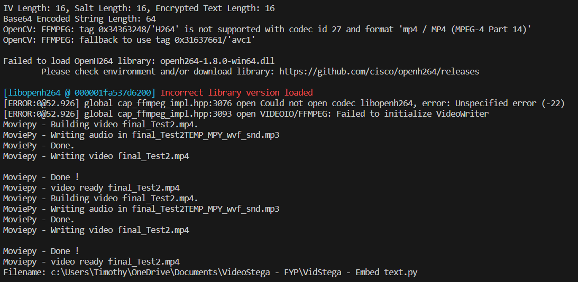

**Figure: 4.10: Video Processing Log with Final Test Results for 1080p Video File using MoviePy**

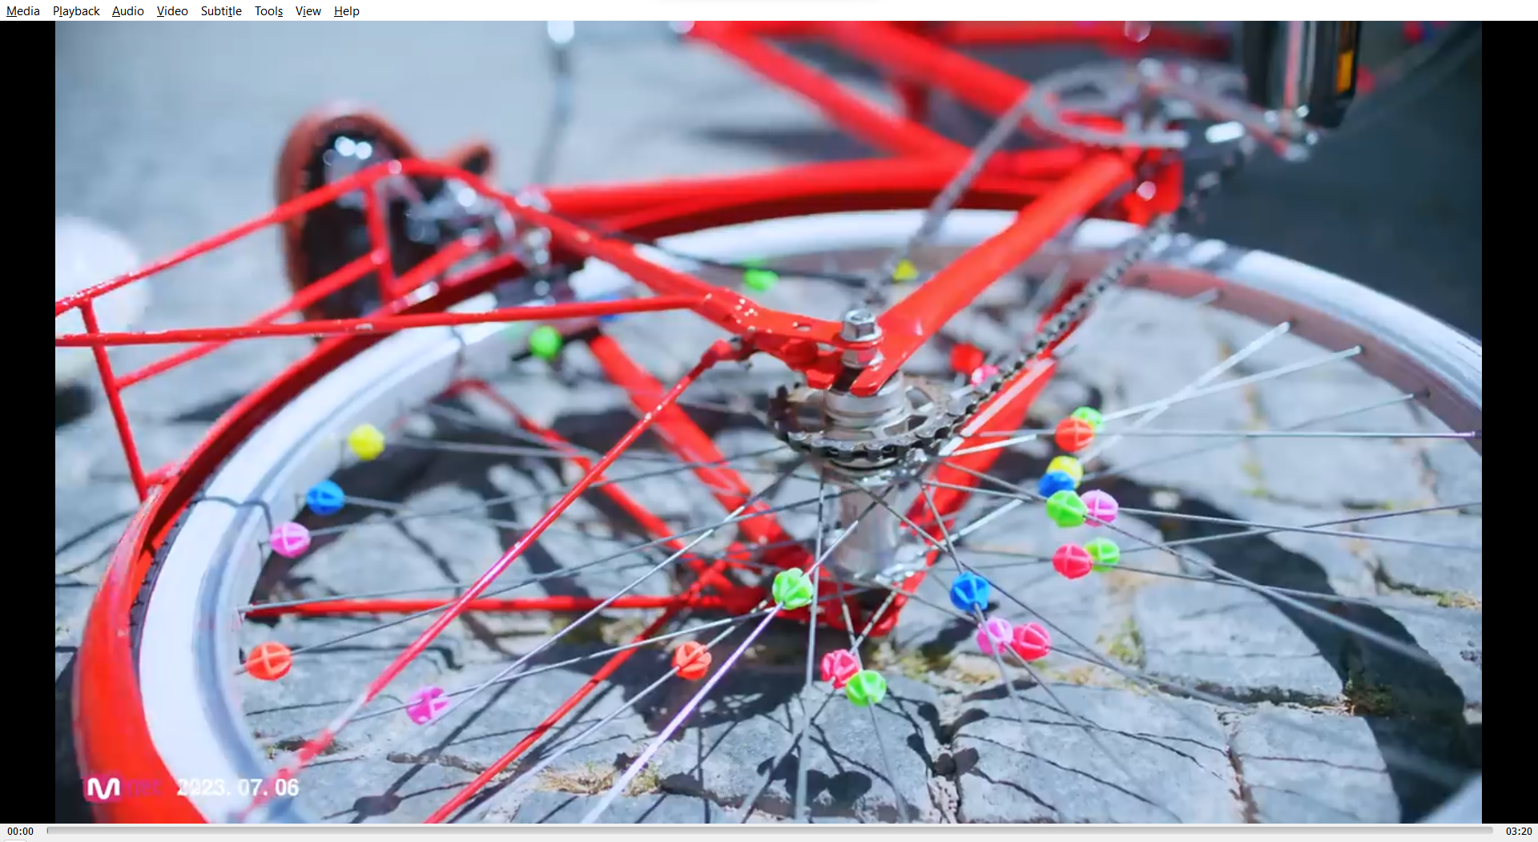

**Figure 4.11 Original 1080p video**



**Figure 4.12 Stego-Video for 1080p**

In the observed test case 3 result, the steganography application demonstrated its capability to effectively process video frames for text embedding using the Least Significant Bit (LSB) technique. The application completed its most extreme task by processing all 4816 frames on a 1080p video with AES-128 and CBC block. The process log provided by the video processing library in Figure 4.10 validated the successful embedding of the text "test" into the video, culminating in the generation of a new video file with the embedded data intact.

Lastly, test case 4 is a comparison of video processing time for each video resolution using AES-256 between CBC and GWM cipher mode. Here’s the bar graph in Figure 4.13 which presents a comparative analysis of the processing times for videos of different resolutions, encrypted using AES-256. It reveals a clear upward trend in processing duration concerning video resolution, with 1080p videos requiring the most time, followed by 720p, and 480p videos completing the fastest. This increase is consistent with the expected computational load presented by higher-resolution videos, which contain a greater number of pixels and therefore more data to process when embedding text into each frame. The timescales illustrated in the graph suggest a non-linear relationship between resolution and processing time, potentially indicating areas where optimization could enhance the application's performance.

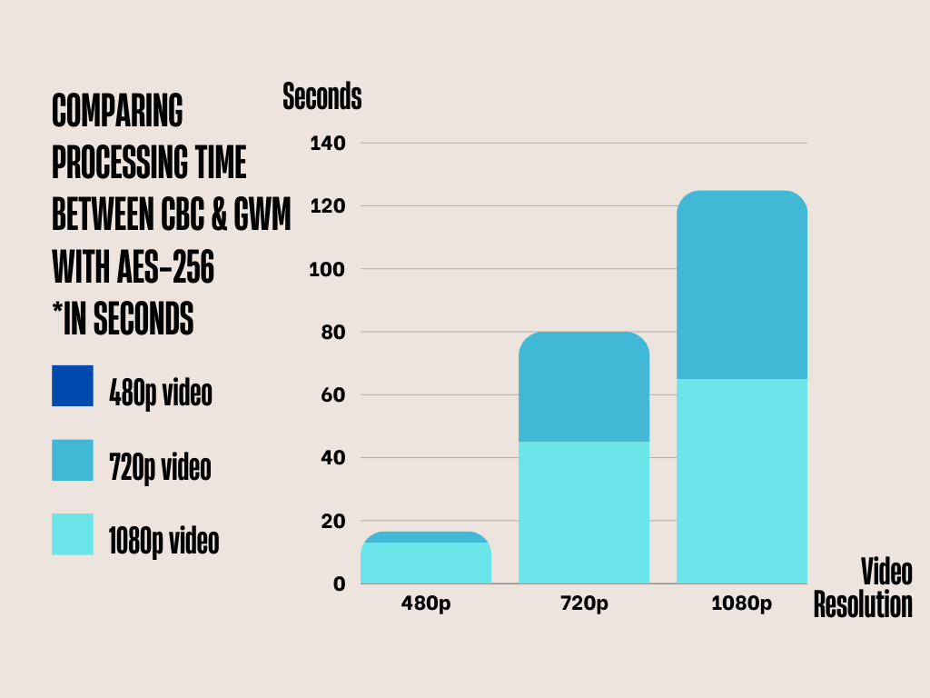

**Figure: 4.13 Comparison Table for Processing Time Between Video Resolution**

The performance review of the steganography application underscores its proficiency in embedding text into video frames effectively, indicating that its primary functions are operating correctly. Nevertheless, the application's ease of use has yet to be assessed, which is essential to ensure it meets end-user needs. A significant finding is that the processing time increases more than linearly with video resolution, suggesting a need for optimization.

Quality control of the video output post-steganography process still needs to be completed, a shortfall that future evaluations could address by incorporating metrics like PSNR. While the application's stability and reliability seem robust, these attributes have yet to be tested under prolonged or intensive use conditions.

In terms of security, although AES-128 encryption is secure, AES-256 could offer enhanced protection for sensitive applications.

Overall, the application shows potential but would benefit from optimizations for high-resolution processing, user experience refinement, and more robust encryption options to improve its overall effectiveness and appeal to users.

# **4.4 Summary of Finding and Discussion**

In summary, the effectiveness of concealing a hidden text within video files has been established across diverse resolutions, encryption methods, and cipher modes. However, a crucial observation pertains to the noticeable rise in processing time as video resolutions escalate, indicating a potential avenue for performance optimizations to bolster overall efficiency. Achieving a delicate equilibrium in the application's performance across varying video qualities and resolutions is imperative for ensuring a smooth and uninterrupted user experience.

To conduct a more comprehensive evaluation of the software, future tests should encompass a broader spectrum of encryption modes. Exploring more different and modern encryption algorithms or modes can contribute to strengthening the security aspect of the steganography process, particularly video and audio. Additionally, assessing the user experience is crucial for the application's usability and accessibility, involving aspects such as the intuitiveness of the interface, responsiveness, and ease of understanding. To enhance user experience, a guideline for utilizing the features need to be showcased across multiple languages and easier to understand.

Furthermore, an in-depth examination of video output quality should be conducted to ensure that the steganography process does not compromise the overall visual integrity of the videos. Long-term reliability testing is essential to verify the robustness of the application over extended periods of usage, providing insights into its stability and sustainability. Addressing these aspects will contribute to the refinement of the video steganography application, making it a more versatile, secure, and user-friendly tool for concealing information within videos across a diverse range of scenarios and requirements.

# **CHAPTER V**

# **CONCLUSION & FUTURE RECOMMENDATIONS**

# **5.1 Conclusion**

In conclusion, the exploration and successful implementation of the Least Significant Bit (LSB) Technique in video steganography have established a robust foundation for achieving secure data embedding within video files. This approach ensures the concealment of information while preserving the integrity and quality of the original video content. The demonstrated capabilities of the LSB Technique open up a plethora of possibilities for future advancements and extensions within this domain.

One of the promising avenues for future work involves the integration of digital watermarking techniques to enhance multimedia content protection. Digital watermarking can add an extra layer of security by uniquely identifying, validating and protecting the intellectual property of multimedia files. This addition could contribute to safeguarding videos especially short video content against unauthorized use or distribution.

Furthermore, expanding the application's capabilities to enhance document security is another noteworthy direction for future research. Integrating steganographic methods into document protection can fortify defences against tampering or unauthorized alterations, ensuring the confidentiality and authenticity of sensitive data. The continuous effort to improve secure communication also presents opportunities for advancing steganography in the digital landscape. Exploring methods to enhance the confidentiality of information during transmission, perhaps through the development of secure communication protocols or improved encryption techniques, could further solidify the role of steganography in ensuring private and protected data exchange.

In essence, the successful implementation of the LSB Technique serves as a stepping stone for future innovations in video steganography. By exploring these potential areas of development, researchers and practitioners can contribute to strengthening the overall capabilities of steganographic tools and pioneering new dimensions of secure communication in the dynamic and ever-evolving digital landscape.

# **5.2 Future Recommendations & Improvements**

Looking ahead of time, the future improvements of the LSB-based steganography tool can be significantly enriched through the integration of advanced encryption standards and sophisticated compression algorithms. Incorporating robust encryption methods, such as AES-256, can fortify the security measures of the tool, ensuring that the embedded data remains highly resistant to decryption attempts or malicious attacks. Additionally, the implementation of efficient compression algorithms can optimize data storage, enabling the tool to conceal larger amounts of information within video files while minimizing the impact on file size.

In terms of security, the adoption of advanced encryption standards would involve the utilization of state-of-the-art cryptographic techniques, adding an extra layer of protection to the steganographic process. This would make it more resilient against sophisticated adversaries and contribute to the overall strength of the tool in safeguarding sensitive information.

Moreover, it is advised that an interactive and user-friendly graphical user interface (GUI) be developed to increase the tool's accessibility and usability, particularly for users who lack or have no technical background. Users can more easily navigate through the tool's capabilities and streamline steganographic operations with an intuitive graphical user interface (GUI).

The interface's intuitive controls, visual aids, and step-by-step instructions would enable users to confidently complete challenging steganography jobs even in the absence of a thorough comprehension of the underlying technological details.In addition to making the GUI easier to use, improvements should also strike a balance between giving users enough control and customisation possibilities.

A seamless and transparent user experience can be enhanced with succinct and clear visual representations of the encryption settings, compression options, and steganographic process. The result would be a sophisticated and formidable instrument in the field of data protection, catering to both security-conscious users and those seeking a user-friendly solution for concealing and securing sensitive information within video files.

# **REFERENCES & BIBLIOGRAPHY**

[1] R. Anderson, and F. Petitcolas, "On the limits of steganography", IEEE Journal of Selected Areas in Communications, Vol. 16, 1998.

[2] Kunhoth, J., Subramanian, N., Al-Maadeed, S. *et al.* Video steganography: recent advances and challenges. *Multimed Tools Appl* **82**, 41943–41985 (2023). <https://doi.org/10.1007/s11042-023-14844-w>

[3] Al-Khater WA, Al-Maadeed S, Ahmed AA et al (2020) Comprehensive review of cybercrime detection techniques. IEEE Access 8:137,293–137,311

[4] poorani, V.N., & L.Jawagar (2014). Audio Based Steganography for Hiding SecretData. International Journal of Innovative Research in Science, Engineering and Technology, 3.

[5] Mstafa, Elleithy & Abdelfattah (2017) Mstafa RJ, Elleithy KM, Abdelfattah E. Video steganography techniques: taxonomy, challenges, and future directions. IEEE long island systems, applications and technology conference (LISAT); Piscataway. 2017. pp. 1–6.

[6] Paul, R., Acharya, A., Yadav, V., & Batham, S. (2013). Hiding large amount of data using a new approach of video steganography. , 337-343. <https://doi.org/10.1049/CP.2013.2338>.

[7] Kasapbaşı, Mustafa Cem & Elmasry, Wisam. (2018). New LSB-based colour image steganography method to enhance the efficiency in payload capacity, security and integrity check. Sādhanā. 43. 10.1007/s12046-018-0848-4.

[8] Ms. Pratidnya Sapate, Ms. Varsha Patil, Ms. Mayuri Pardeshi,Prof. Arjun Nichal, A Review Paper on Video Steganography, IARJ SET, ISO 3297:2007 Certified Vol. 3, Issue 12, December 2016

[9] Ramalingam, M., & Isa, N.A. (2014). A steganography approach for sequential data encoding and decoding in video images. 2014 International Conference on Computer, Control, Informatics and Its Applications (IC3INA), 120-125.

[10] Kelash et al. (2013) Kelash HM, Wahab OFA, Elshakankiry OA, El-sayed HS. Hiding data in video sequences using steganography algorithms. IEEE international conference on ICT convergence (ICTC); Piscataway. 2013. pp. 353–358.

[11] Chitra, S., & Thoti, N. (2013). Implementation of Video Steganography Using Hash Function in LSB Technique. International journal of engineering research and technology,2.

[12] Sadek, Khalifa & Mostafa (2015) Sadek MM, Khalifa AS, Mostafa MG-HM. Robust video steganography algorithm using adaptive skin-tone detection. *Multimedia Tools and Applications.*2015; 76:3065–3085

[13] Khupse & Patil (2014) Khupse S, Patil NN. An adaptive steganography technique for videos using Steganoflage. IEEE international conference on issues and challenges in intelligent computing techniques (ICICT); Piscataway. 2014. pp. 811–815

[14] Alavianmehr et al. (2012) Alavianmehr MA, Rezaei M, Helfroush MS, Tashk A. A lossless data hiding scheme on video raw data robust against H.264/AVC compression. 2012 2nd international econference on computer and knowledge engineering (ICCKE); 2012. pp. 194–198

[15] Noda et al. (2004) Noda H, Furuta T, Niimi M, Kawaguchi E. Application of BPCS steganography to wavelet compressed video. 2004 international conference on image processing, 2004. ICIP ’04, Vol. 4; 2004. pp. 2147–2150.

[16] Kapoor & Mirza (2015) Kapoor V, Mirza A. An enhanced LSB based video steganographic system for secure and efficient data transmission. *International Journal of Computer Applications.*2015;121(10):38–42. doi: 10.5120/21580-4649.

[17] B. Chandel, and S. Jain, "Video Steganography: A Survey." IOSR Journal of Computer Engineering (IOSR-JCE), 18(1), 11-17, 2016.

[18] C. H. Yang, C. Y. Weng, S. J. Wang, and H. M. Sun, "Adaptive Data Hiding in Edge Areas of Images with Spatial LSB Domain Systems." IEEE Transactions on Information Forensics and Security, 3(3), 488-497, 2008

[19] Kaur, R., Pooja, & Varsha (2016). A hybrid approach for video steganography using edge detection and identical match techniques. 2016 International Conference on Wireless Communications, Signal Processing and Networking (WiSPNET), 867-871.

[20] Daemen, J. & Rijmen, Vincent. (2002). AES the Advanced Encryption Standard. The Design of Rijndael. 26.

[21] Rao, S., Mahto, D., & Khan, D. (2017). A Survey on Advanced Encryption Standard. . <https://doi.org/10.21275/art20164149>.

[22] Paar, Christof & Pelzl, Jan. (2010). Understanding cryptography. A textbook for students and practitioners. Foreword by Bart Preneel. 10.1007/978-3-642-04101-3.

[23] Than, Shwe. (2020). Secure Data Transmission in Video Format Based on LSB and Huffman Coding. International Journal of Image, Graphics and Signal Processing. 12. 10-17. 10.5815/ijigsp.2020.01.02.

[24] Lee, Haeyoung. (2018). Data Hiding in Spatial Color Images on Smartphones by Adaptive R-G-B LSB Replacement. IEICE Transactions on Information and Systems. E101.D. 2163-2167. 10.1587/transinf.2017EDL8232.

[25] Swain, G. Very High-Capacity Image Steganography Technique Using Quotient Value Differencing and LSB Substitution. *Arab J Sci Eng* **44**, 2995–3004 (2019). <https://doi.org/10.1007/s13369-018-3372-2>

[26] P, Malathi & K, Praneeth & S, Phani & B, Rohith & T, Nayana. (2023). DNA Steganography using RNA codons and Amino acids. 1-7. 10.1109/ICCCNT56998.2023.10307974.

[27] Bhattacharyya, D., Bhaumik, A.K., Choi, M., Kim, Th. (2010). Directed Graph Pattern Synthesis in LSB Technique on Video Steganography. In: Kim, Th., Adeli, H. (eds) Advances in Computer Science and Information Technology. AST ACN 2010 2010. Lecture Notes in Computer Science, vol 6059. Springer, Berlin, Heidelberg. <https://doi.org/10.1007/978-3-642-13577-4_6>

[28] Diop, I., Farssi, S., Khouma, O., & Diouf, H. (2012). New Steganographic scheme based of Reed- Solomon codes. International Journal of Distributed and Parallel systems, 3, 81-89. <https://doi.org/10.5121/IJDPS.2012.3207>.

[29] Xu, J. (2022). Improved least significant bit algorithm based on RS-code. , 12475, 124751I - 124751I-5. <https://doi.org/10.1117/12.2659479>.

[30] Banerjee, A., & Jana, B. (2019). A robust reversible data hiding scheme for color image using reed-solomon code. Multimedia Tools and Applications, 78, 24903 - 24922. <https://doi.org/10.1007/s11042-019-7626-0>.

[31] Rui, S. (2005). Digital image Watermarking Technique Based on 2-d Barcode. Journal of Wuhan Institute of Shipbuilding Technology.

[32] OpenPuff tool - <https://embeddedsw.net/OpenPuff_Steganography_Home.html>

[33] Related Products - https://www.ilovefreesoftware.com/31/featured/free-video-steganography-software.html